The Boston house-price data of Harrison, D. and Rubinfeld, D.L. 'Hedonic

prices and the demand for clean air', J. Environ. Economics & Management,

vol.5, 81-102, 1978. Used in Belsley, Kuh & Welsch, 'Regression diagnostics

...', Wiley, 1980. N.B. Various transformations are used in the table on

pages 244-261 of the latter.

Variables in order:

CRIM per capita crime rate by town

ZN proportion of residential land zoned for lots over 25,000 sq.ft.

INDUS proportion of non-retail business acres per town

CHAS Charles River dummy variable (= 1 if tract bounds river; 0 otherwise)

NOX nitric oxides concentration (parts per 10 million)

RM average number of rooms per dwelling

AGE proportion of owner-occupied units built prior to 1940

DIS weighted distances to five Boston employment centres

RAD index of accessibility to radial highways

TAX full-value property-tax rate per $10,000

PTRATIO pupil-teacher ratio by town

B 1000(Bk - 0.63)^2 where Bk is the proportion of blacks by town

LSTAT % lower status of the population

MEDV Median value of owner-occupied homes in $1000's

0.00632 18.00 2.310 0 0.5380 6.5750 65.20 4.0900 1 296.0 15.30

396.90 4.98 24.00

0.02731 0.00 7.070 0 0.4690 6.4210 78.90 4.9671 2 242.0 17.80

396.90 9.14 21.60

0.02729 0.00 7.070 0 0.4690 7.1850 61.10 4.9671 2 242.0 17.80

392.83 4.03 34.70

0.03237 0.00 2.180 0 0.4580 6.9980 45.80 6.0622 3 222.0 18.70

394.63 2.94 33.40

0.06905 0.00 2.180 0 0.4580 7.1470 54.20 6.0622 3 222.0 18.70

396.90 5.33 36.20

0.02985 0.00 2.180 0 0.4580 6.4300 58.70 6.0622 3 222.0 18.70

394.12 5.21 28.70

0.08829 12.50 7.870 0 0.5240 6.0120 66.60 5.5605 5 311.0 15.20

395.60 12.43 22.90

0.14455 12.50 7.870 0 0.5240 6.1720 96.10 5.9505 5 311.0 15.20

396.90 19.15 27.10

0.21124 12.50 7.870 0 0.5240 5.6310 100.00 6.0821 5 311.0 15.20

386.63 29.93 16.50

0.17004 12.50 7.870 0 0.5240 6.0040 85.90 6.5921 5 311.0 15.20

386.71 17.10 18.90

0.22489 12.50 7.870 0 0.5240 6.3770 94.30 6.3467 5 311.0 15.20

392.52 20.45 15.00

0.11747 12.50 7.870 0 0.5240 6.0090 82.90 6.2267 5 311.0 15.20

396.90 13.27 18.90

0.09378 12.50 7.870 0 0.5240 5.8890 39.00 5.4509 5 311.0 15.20

390.50 15.71 21.70

0.62976 0.00 8.140 0 0.5380 5.9490 61.80 4.7075 4 307.0 21.00

396.90 8.26 20.40

0.63796 0.00 8.140 0 0.5380 6.0960 84.50 4.4619 4 307.0 21.00

380.02 10.26 18.20

0.62739 0.00 8.140 0 0.5380 5.8340 56.50 4.4986 4 307.0 21.00

395.62 8.47 19.90

1.05393 0.00 8.140 0 0.5380 5.9350 29.30 4.4986 4 307.0 21.00

386.85 6.58 23.10

0.78420 0.00 8.140 0 0.5380 5.9900 81.70 4.2579 4 307.0 21.00

386.75 14.67 17.50

0.80271 0.00 8.140 0 0.5380 5.4560 36.60 3.7965 4 307.0 21.00

288.99 11.69 20.20

0.72580 0.00 8.140 0 0.5380 5.7270 69.50 3.7965 4 307.0 21.00

390.95 11.28 18.20

1.25179 0.00 8.140 0 0.5380 5.5700 98.10 3.7979 4 307.0 21.00

376.57 21.02 13.60

0.85204 0.00 8.140 0 0.5380 5.9650 89.20 4.0123 4 307.0 21.00

392.53 13.83 19.60

1.23247 0.00 8.140 0 0.5380 6.1420 91.70 3.9769 4 307.0 21.00

396.90 18.72 15.20

0.98843 0.00 8.140 0 0.5380 5.8130 100.00 4.0952 4 307.0 21.00

394.54 19.88 14.50

0.75026 0.00 8.140 0 0.5380 5.9240 94.10 4.3996 4 307.0 21.00

394.33 16.30 15.60

0.84054 0.00 8.140 0 0.5380 5.5990 85.70 4.4546 4 307.0 21.00

303.42 16.51 13.90

0.67191 0.00 8.140 0 0.5380 5.8130 90.30 4.6820 4 307.0 21.00

376.88 14.81 16.60

0.95577 0.00 8.140 0 0.5380 6.0470 88.80 4.4534 4 307.0 21.00

306.38 17.28 14.80

0.77299 0.00 8.140 0 0.5380 6.4950 94.40 4.4547 4 307.0 21.00

387.94 12.80 18.40

1.00245 0.00 8.140 0 0.5380 6.6740 87.30 4.2390 4 307.0 21.00

380.23 11.98 21.00

1.13081 0.00 8.140 0 0.5380 5.7130 94.10 4.2330 4 307.0 21.00

360.17 22.60 12.70

1.35472 0.00 8.140 0 0.5380 6.0720 100.00 4.1750 4 307.0 21.00

376.73 13.04 14.50

1.38799 0.00 8.140 0 0.5380 5.9500 82.00 3.9900 4 307.0 21.00

232.60 27.71 13.20

1.15172 0.00 8.140 0 0.5380 5.7010 95.00 3.7872 4 307.0 21.00

358.77 18.35 13.10

1.61282 0.00 8.140 0 0.5380 6.0960 96.90 3.7598 4 307.0 21.00

248.31 20.34 13.50

0.06417 0.00 5.960 0 0.4990 5.9330 68.20 3.3603 5 279.0 19.20

396.90 9.68 18.90

0.09744 0.00 5.960 0 0.4990 5.8410 61.40 3.3779 5 279.0 19.20

377.56 11.41 20.00

0.08014 0.00 5.960 0 0.4990 5.8500 41.50 3.9342 5 279.0 19.20

396.90 8.77 21.00

0.17505 0.00 5.960 0 0.4990 5.9660 30.20 3.8473 5 279.0 19.20

393.43 10.13 24.70

0.02763 75.00 2.950 0 0.4280 6.5950 21.80 5.4011 3 252.0 18.30

395.63 4.32 30.80

0.03359 75.00 2.950 0 0.4280 7.0240 15.80 5.4011 3 252.0 18.30

395.62 1.98 34.90

0.12744 0.00 6.910 0 0.4480 6.7700 2.90 5.7209 3 233.0 17.90

385.41 4.84 26.60

0.14150 0.00 6.910 0 0.4480 6.1690 6.60 5.7209 3 233.0 17.90

383.37 5.81 25.30

0.15936 0.00 6.910 0 0.4480 6.2110 6.50 5.7209 3 233.0 17.90

394.46 7.44 24.70

0.12269 0.00 6.910 0 0.4480 6.0690 40.00 5.7209 3 233.0 17.90

389.39 9.55 21.20

0.17142 0.00 6.910 0 0.4480 5.6820 33.80 5.1004 3 233.0 17.90

396.90 10.21 19.30

0.18836 0.00 6.910 0 0.4480 5.7860 33.30 5.1004 3 233.0 17.90

396.90 14.15 20.00

0.22927 0.00 6.910 0 0.4480 6.0300 85.50 5.6894 3 233.0 17.90

392.74 18.80 16.60

0.25387 0.00 6.910 0 0.4480 5.3990 95.30 5.8700 3 233.0 17.90

396.90 30.81 14.40

0.21977 0.00 6.910 0 0.4480 5.6020 62.00 6.0877 3 233.0 17.90

396.90 16.20 19.40

0.08873 21.00 5.640 0 0.4390 5.9630 45.70 6.8147 4 243.0 16.80

395.56 13.45 19.70

0.04337 21.00 5.640 0 0.4390 6.1150 63.00 6.8147 4 243.0 16.80

393.97 9.43 20.50

0.05360 21.00 5.640 0 0.4390 6.5110 21.10 6.8147 4 243.0 16.80

396.90 5.28 25.00

0.04981 21.00 5.640 0 0.4390 5.9980 21.40 6.8147 4 243.0 16.80

396.90 8.43 23.40

0.01360 75.00 4.000 0 0.4100 5.8880 47.60 7.3197 3 469.0 21.10

396.90 14.80 18.90

0.01311 90.00 1.220 0 0.4030 7.2490 21.90 8.6966 5 226.0 17.90

395.93 4.81 35.40

0.02055 85.00 0.740 0 0.4100 6.3830 35.70 9.1876 2 313.0 17.30

396.90 5.77 24.70

0.01432 100.00 1.320 0 0.4110 6.8160 40.50 8.3248 5 256.0 15.10

392.90 3.95 31.60

0.15445 25.00 5.130 0 0.4530 6.1450 29.20 7.8148 8 284.0 19.70

390.68 6.86 23.30

0.10328 25.00 5.130 0 0.4530 5.9270 47.20 6.9320 8 284.0 19.70

396.90 9.22 19.60

0.14932 25.00 5.130 0 0.4530 5.7410 66.20 7.2254 8 284.0 19.70

395.11 13.15 18.70

0.17171 25.00 5.130 0 0.4530 5.9660 93.40 6.8185 8 284.0 19.70

378.08 14.44 16.00

0.11027 25.00 5.130 0 0.4530 6.4560 67.80 7.2255 8 284.0 19.70

396.90 6.73 22.20

0.12650 25.00 5.130 0 0.4530 6.7620 43.40 7.9809 8 284.0 19.70

395.58 9.50 25.00

0.01951 17.50 1.380 0 0.4161 7.1040 59.50 9.2229 3 216.0 18.60

393.24 8.05 33.00

0.03584 80.00 3.370 0 0.3980 6.2900 17.80 6.6115 4 337.0 16.10

396.90 4.67 23.50

0.04379 80.00 3.370 0 0.3980 5.7870 31.10 6.6115 4 337.0 16.10

396.90 10.24 19.40

0.05789 12.50 6.070 0 0.4090 5.8780 21.40 6.4980 4 345.0 18.90

396.21 8.10 22.00

0.13554 12.50 6.070 0 0.4090 5.5940 36.80 6.4980 4 345.0 18.90

396.90 13.09 17.40

0.12816 12.50 6.070 0 0.4090 5.8850 33.00 6.4980 4 345.0 18.90

396.90 8.79 20.90

0.08826 0.00 10.810 0 0.4130 6.4170 6.60 5.2873 4 305.0 19.20

383.73 6.72 24.20

0.15876 0.00 10.810 0 0.4130 5.9610 17.50 5.2873 4 305.0 19.20

376.94 9.88 21.70

0.09164 0.00 10.810 0 0.4130 6.0650 7.80 5.2873 4 305.0 19.20

390.91 5.52 22.80

0.19539 0.00 10.810 0 0.4130 6.2450 6.20 5.2873 4 305.0 19.20

377.17 7.54 23.40

0.07896 0.00 12.830 0 0.4370 6.2730 6.00 4.2515 5 398.0 18.70

394.92 6.78 24.10

0.09512 0.00 12.830 0 0.4370 6.2860 45.00 4.5026 5 398.0 18.70

383.23 8.94 21.40

0.10153 0.00 12.830 0 0.4370 6.2790 74.50 4.0522 5 398.0 18.70

373.66 11.97 20.00

0.08707 0.00 12.830 0 0.4370 6.1400 45.80 4.0905 5 398.0 18.70

386.96 10.27 20.80

0.05646 0.00 12.830 0 0.4370 6.2320 53.70 5.0141 5 398.0 18.70

386.40 12.34 21.20

0.08387 0.00 12.830 0 0.4370 5.8740 36.60 4.5026 5 398.0 18.70

396.06 9.10 20.30

0.04113 25.00 4.860 0 0.4260 6.7270 33.50 5.4007 4 281.0 19.00

396.90 5.29 28.00

0.04462 25.00 4.860 0 0.4260 6.6190 70.40 5.4007 4 281.0 19.00

395.63 7.22 23.90

0.03659 25.00 4.860 0 0.4260 6.3020 32.20 5.4007 4 281.0 19.00

396.90 6.72 24.80

0.03551 25.00 4.860 0 0.4260 6.1670 46.70 5.4007 4 281.0 19.00

390.64 7.51 22.90

0.05059 0.00 4.490 0 0.4490 6.3890 48.00 4.7794 3 247.0 18.50

396.90 9.62 23.90

0.05735 0.00 4.490 0 0.4490 6.6300 56.10 4.4377 3 247.0 18.50

392.30 6.53 26.60

0.05188 0.00 4.490 0 0.4490 6.0150 45.10 4.4272 3 247.0 18.50

395.99 12.86 22.50

0.07151 0.00 4.490 0 0.4490 6.1210 56.80 3.7476 3 247.0 18.50

395.15 8.44 22.20

0.05660 0.00 3.410 0 0.4890 7.0070 86.30 3.4217 2 270.0 17.80

396.90 5.50 23.60

0.05302 0.00 3.410 0 0.4890 7.0790 63.10 3.4145 2 270.0 17.80

396.06 5.70 28.70

0.04684 0.00 3.410 0 0.4890 6.4170 66.10 3.0923 2 270.0 17.80

392.18 8.81 22.60

0.03932 0.00 3.410 0 0.4890 6.4050 73.90 3.0921 2 270.0 17.80

393.55 8.20 22.00

0.04203 28.00 15.040 0 0.4640 6.4420 53.60 3.6659 4 270.0 18.20

395.01 8.16 22.90

0.02875 28.00 15.040 0 0.4640 6.2110 28.90 3.6659 4 270.0 18.20

396.33 6.21 25.00

0.04294 28.00 15.040 0 0.4640 6.2490 77.30 3.6150 4 270.0 18.20

396.90 10.59 20.60

0.12204 0.00 2.890 0 0.4450 6.6250 57.80 3.4952 2 276.0 18.00

357.98 6.65 28.40

0.11504 0.00 2.890 0 0.4450 6.1630 69.60 3.4952 2 276.0 18.00

391.83 11.34 21.40

0.12083 0.00 2.890 0 0.4450 8.0690 76.00 3.4952 2 276.0 18.00

396.90 4.21 38.70

0.08187 0.00 2.890 0 0.4450 7.8200 36.90 3.4952 2 276.0 18.00

393.53 3.57 43.80

0.06860 0.00 2.890 0 0.4450 7.4160 62.50 3.4952 2 276.0 18.00

396.90 6.19 33.20

0.14866 0.00 8.560 0 0.5200 6.7270 79.90 2.7778 5 384.0 20.90

394.76 9.42 27.50

0.11432 0.00 8.560 0 0.5200 6.7810 71.30 2.8561 5 384.0 20.90

395.58 7.67 26.50

0.22876 0.00 8.560 0 0.5200 6.4050 85.40 2.7147 5 384.0 20.90

70.80 10.63 18.60

0.21161 0.00 8.560 0 0.5200 6.1370 87.40 2.7147 5 384.0 20.90

394.47 13.44 19.30

0.13960 0.00 8.560 0 0.5200 6.1670 90.00 2.4210 5 384.0 20.90

392.69 12.33 20.10

0.13262 0.00 8.560 0 0.5200 5.8510 96.70 2.1069 5 384.0 20.90

394.05 16.47 19.50

0.17120 0.00 8.560 0 0.5200 5.8360 91.90 2.2110 5 384.0 20.90

395.67 18.66 19.50

0.13117 0.00 8.560 0 0.5200 6.1270 85.20 2.1224 5 384.0 20.90

387.69 14.09 20.40

0.12802 0.00 8.560 0 0.5200 6.4740 97.10 2.4329 5 384.0 20.90

395.24 12.27 19.80

0.26363 0.00 8.560 0 0.5200 6.2290 91.20 2.5451 5 384.0 20.90

391.23 15.55 19.40

0.10793 0.00 8.560 0 0.5200 6.1950 54.40 2.7778 5 384.0 20.90

393.49 13.00 21.70

0.10084 0.00 10.010 0 0.5470 6.7150 81.60 2.6775 6 432.0 17.80

395.59 10.16 22.80

0.12329 0.00 10.010 0 0.5470 5.9130 92.90 2.3534 6 432.0 17.80

394.95 16.21 18.80

0.22212 0.00 10.010 0 0.5470 6.0920 95.40 2.5480 6 432.0 17.80

396.90 17.09 18.70

0.14231 0.00 10.010 0 0.5470 6.2540 84.20 2.2565 6 432.0 17.80

388.74 10.45 18.50

0.17134 0.00 10.010 0 0.5470 5.9280 88.20 2.4631 6 432.0 17.80

344.91 15.76 18.30

0.13158 0.00 10.010 0 0.5470 6.1760 72.50 2.7301 6 432.0 17.80

393.30 12.04 21.20

0.15098 0.00 10.010 0 0.5470 6.0210 82.60 2.7474 6 432.0 17.80

394.51 10.30 19.20

0.13058 0.00 10.010 0 0.5470 5.8720 73.10 2.4775 6 432.0 17.80

338.63 15.37 20.40

0.14476 0.00 10.010 0 0.5470 5.7310 65.20 2.7592 6 432.0 17.80

391.50 13.61 19.30

0.06899 0.00 25.650 0 0.5810 5.8700 69.70 2.2577 2 188.0 19.10

389.15 14.37 22.00

0.07165 0.00 25.650 0 0.5810 6.0040 84.10 2.1974 2 188.0 19.10

377.67 14.27 20.30

0.09299 0.00 25.650 0 0.5810 5.9610 92.90 2.0869 2 188.0 19.10

378.09 17.93 20.50

0.15038 0.00 25.650 0 0.5810 5.8560 97.00 1.9444 2 188.0 19.10

370.31 25.41 17.30

0.09849 0.00 25.650 0 0.5810 5.8790 95.80 2.0063 2 188.0 19.10

379.38 17.58 18.80

0.16902 0.00 25.650 0 0.5810 5.9860 88.40 1.9929 2 188.0 19.10

385.02 14.81 21.40

0.38735 0.00 25.650 0 0.5810 5.6130 95.60 1.7572 2 188.0 19.10

359.29 27.26 15.70

0.25915 0.00 21.890 0 0.6240 5.6930 96.00 1.7883 4 437.0 21.20

392.11 17.19 16.20

0.32543 0.00 21.890 0 0.6240 6.4310 98.80 1.8125 4 437.0 21.20

396.90 15.39 18.00

0.88125 0.00 21.890 0 0.6240 5.6370 94.70 1.9799 4 437.0 21.20

396.90 18.34 14.30

0.34006 0.00 21.890 0 0.6240 6.4580 98.90 2.1185 4 437.0 21.20

395.04 12.60 19.20

1.19294 0.00 21.890 0 0.6240 6.3260 97.70 2.2710 4 437.0 21.20

396.90 12.26 19.60

0.59005 0.00 21.890 0 0.6240 6.3720 97.90 2.3274 4 437.0 21.20

385.76 11.12 23.00

0.32982 0.00 21.890 0 0.6240 5.8220 95.40 2.4699 4 437.0 21.20

388.69 15.03 18.40

0.97617 0.00 21.890 0 0.6240 5.7570 98.40 2.3460 4 437.0 21.20

262.76 17.31 15.60

0.55778 0.00 21.890 0 0.6240 6.3350 98.20 2.1107 4 437.0 21.20

394.67 16.96 18.10

0.32264 0.00 21.890 0 0.6240 5.9420 93.50 1.9669 4 437.0 21.20

378.25 16.90 17.40

0.35233 0.00 21.890 0 0.6240 6.4540 98.40 1.8498 4 437.0 21.20

394.08 14.59 17.10

0.24980 0.00 21.890 0 0.6240 5.8570 98.20 1.6686 4 437.0 21.20

392.04 21.32 13.30

0.54452 0.00 21.890 0 0.6240 6.1510 97.90 1.6687 4 437.0 21.20

396.90 18.46 17.80

0.29090 0.00 21.890 0 0.6240 6.1740 93.60 1.6119 4 437.0 21.20

388.08 24.16 14.00

1.62864 0.00 21.890 0 0.6240 5.0190 100.00 1.4394 4 437.0 21.20

396.90 34.41 14.40

3.32105 0.00 19.580 1 0.8710 5.4030 100.00 1.3216 5 403.0 14.70

396.90 26.82 13.40

4.09740 0.00 19.580 0 0.8710 5.4680 100.00 1.4118 5 403.0 14.70

396.90 26.42 15.60

2.77974 0.00 19.580 0 0.8710 4.9030 97.80 1.3459 5 403.0 14.70

396.90 29.29 11.80

2.37934 0.00 19.580 0 0.8710 6.1300 100.00 1.4191 5 403.0 14.70

172.91 27.80 13.80

2.15505 0.00 19.580 0 0.8710 5.6280 100.00 1.5166 5 403.0 14.70

169.27 16.65 15.60

2.36862 0.00 19.580 0 0.8710 4.9260 95.70 1.4608 5 403.0 14.70

391.71 29.53 14.60

2.33099 0.00 19.580 0 0.8710 5.1860 93.80 1.5296 5 403.0 14.70

356.99 28.32 17.80

2.73397 0.00 19.580 0 0.8710 5.5970 94.90 1.5257 5 403.0 14.70

351.85 21.45 15.40

1.65660 0.00 19.580 0 0.8710 6.1220 97.30 1.6180 5 403.0 14.70

372.80 14.10 21.50

1.49632 0.00 19.580 0 0.8710 5.4040 100.00 1.5916 5 403.0 14.70

341.60 13.28 19.60

1.12658 0.00 19.580 1 0.8710 5.0120 88.00 1.6102 5 403.0 14.70

343.28 12.12 15.30

2.14918 0.00 19.580 0 0.8710 5.7090 98.50 1.6232 5 403.0 14.70

261.95 15.79 19.40

1.41385 0.00 19.580 1 0.8710 6.1290 96.00 1.7494 5 403.0 14.70

321.02 15.12 17.00

3.53501 0.00 19.580 1 0.8710 6.1520 82.60 1.7455 5 403.0 14.70

88.01 15.02 15.60

2.44668 0.00 19.580 0 0.8710 5.2720 94.00 1.7364 5 403.0 14.70

88.63 16.14 13.10

1.22358 0.00 19.580 0 0.6050 6.9430 97.40 1.8773 5 403.0 14.70

363.43 4.59 41.30

1.34284 0.00 19.580 0 0.6050 6.0660 100.00 1.7573 5 403.0 14.70

353.89 6.43 24.30

1.42502 0.00 19.580 0 0.8710 6.5100 100.00 1.7659 5 403.0 14.70

364.31 7.39 23.30

1.27346 0.00 19.580 1 0.6050 6.2500 92.60 1.7984 5 403.0 14.70

338.92 5.50 27.00

1.46336 0.00 19.580 0 0.6050 7.4890 90.80 1.9709 5 403.0 14.70

374.43 1.73 50.00

1.83377 0.00 19.580 1 0.6050 7.8020 98.20 2.0407 5 403.0 14.70

389.61 1.92 50.00

1.51902 0.00 19.580 1 0.6050 8.3750 93.90 2.1620 5 403.0 14.70

388.45 3.32 50.00

2.24236 0.00 19.580 0 0.6050 5.8540 91.80 2.4220 5 403.0 14.70

395.11 11.64 22.70

2.92400 0.00 19.580 0 0.6050 6.1010 93.00 2.2834 5 403.0 14.70

240.16 9.81 25.00

2.01019 0.00 19.580 0 0.6050 7.9290 96.20 2.0459 5 403.0 14.70

369.30 3.70 50.00

1.80028 0.00 19.580 0 0.6050 5.8770 79.20 2.4259 5 403.0 14.70

227.61 12.14 23.80

2.30040 0.00 19.580 0 0.6050 6.3190 96.10 2.1000 5 403.0 14.70

297.09 11.10 23.80

2.44953 0.00 19.580 0 0.6050 6.4020 95.20 2.2625 5 403.0 14.70

330.04 11.32 22.30

1.20742 0.00 19.580 0 0.6050 5.8750 94.60 2.4259 5 403.0 14.70

292.29 14.43 17.40

2.31390 0.00 19.580 0 0.6050 5.8800 97.30 2.3887 5 403.0 14.70

348.13 12.03 19.10

0.13914 0.00 4.050 0 0.5100 5.5720 88.50 2.5961 5 296.0 16.60

396.90 14.69 23.10

0.09178 0.00 4.050 0 0.5100 6.4160 84.10 2.6463 5 296.0 16.60

395.50 9.04 23.60

0.08447 0.00 4.050 0 0.5100 5.8590 68.70 2.7019 5 296.0 16.60

393.23 9.64 22.60

0.06664 0.00 4.050 0 0.5100 6.5460 33.10 3.1323 5 296.0 16.60

390.96 5.33 29.40

0.07022 0.00 4.050 0 0.5100 6.0200 47.20 3.5549 5 296.0 16.60

393.23 10.11 23.20

0.05425 0.00 4.050 0 0.5100 6.3150 73.40 3.3175 5 296.0 16.60

395.60 6.29 24.60

0.06642 0.00 4.050 0 0.5100 6.8600 74.40 2.9153 5 296.0 16.60

391.27 6.92 29.90

0.05780 0.00 2.460 0 0.4880 6.9800 58.40 2.8290 3 193.0 17.80

396.90 5.04 37.20

0.06588 0.00 2.460 0 0.4880 7.7650 83.30 2.7410 3 193.0 17.80

395.56 7.56 39.80

0.06888 0.00 2.460 0 0.4880 6.1440 62.20 2.5979 3 193.0 17.80

396.90 9.45 36.20

0.09103 0.00 2.460 0 0.4880 7.1550 92.20 2.7006 3 193.0 17.80

394.12 4.82 37.90

0.10008 0.00 2.460 0 0.4880 6.5630 95.60 2.8470 3 193.0 17.80

396.90 5.68 32.50

0.08308 0.00 2.460 0 0.4880 5.6040 89.80 2.9879 3 193.0 17.80

391.00 13.98 26.40

0.06047 0.00 2.460 0 0.4880 6.1530 68.80 3.2797 3 193.0 17.80

387.11 13.15 29.60

0.05602 0.00 2.460 0 0.4880 7.8310 53.60 3.1992 3 193.0 17.80

392.63 4.45 50.00

0.07875 45.00 3.440 0 0.4370 6.7820 41.10 3.7886 5 398.0 15.20

393.87 6.68 32.00

0.12579 45.00 3.440 0 0.4370 6.5560 29.10 4.5667 5 398.0 15.20

382.84 4.56 29.80

0.08370 45.00 3.440 0 0.4370 7.1850 38.90 4.5667 5 398.0 15.20

396.90 5.39 34.90

0.09068 45.00 3.440 0 0.4370 6.9510 21.50 6.4798 5 398.0 15.20

377.68 5.10 37.00

0.06911 45.00 3.440 0 0.4370 6.7390 30.80 6.4798 5 398.0 15.20

389.71 4.69 30.50

0.08664 45.00 3.440 0 0.4370 7.1780 26.30 6.4798 5 398.0 15.20

390.49 2.87 36.40

0.02187 60.00 2.930 0 0.4010 6.8000 9.90 6.2196 1 265.0 15.60

393.37 5.03 31.10

0.01439 60.00 2.930 0 0.4010 6.6040 18.80 6.2196 1 265.0 15.60

376.70 4.38 29.10

0.01381 80.00 0.460 0 0.4220 7.8750 32.00 5.6484 4 255.0 14.40

394.23 2.97 50.00

0.04011 80.00 1.520 0 0.4040 7.2870 34.10 7.3090 2 329.0 12.60

396.90 4.08 33.30

0.04666 80.00 1.520 0 0.4040 7.1070 36.60 7.3090 2 329.0 12.60

354.31 8.61 30.30

0.03768 80.00 1.520 0 0.4040 7.2740 38.30 7.3090 2 329.0 12.60

392.20 6.62 34.60

0.03150 95.00 1.470 0 0.4030 6.9750 15.30 7.6534 3 402.0 17.00

396.90 4.56 34.90

0.01778 95.00 1.470 0 0.4030 7.1350 13.90 7.6534 3 402.0 17.00

384.30 4.45 32.90

0.03445 82.50 2.030 0 0.4150 6.1620 38.40 6.2700 2 348.0 14.70

393.77 7.43 24.10

0.02177 82.50 2.030 0 0.4150 7.6100 15.70 6.2700 2 348.0 14.70

395.38 3.11 42.30

0.03510 95.00 2.680 0 0.4161 7.8530 33.20 5.1180 4 224.0 14.70

392.78 3.81 48.50

0.02009 95.00 2.680 0 0.4161 8.0340 31.90 5.1180 4 224.0 14.70

390.55 2.88 50.00

0.13642 0.00 10.590 0 0.4890 5.8910 22.30 3.9454 4 277.0 18.60

396.90 10.87 22.60

0.22969 0.00 10.590 0 0.4890 6.3260 52.50 4.3549 4 277.0 18.60

394.87 10.97 24.40

0.25199 0.00 10.590 0 0.4890 5.7830 72.70 4.3549 4 277.0 18.60

389.43 18.06 22.50

0.13587 0.00 10.590 1 0.4890 6.0640 59.10 4.2392 4 277.0 18.60

381.32 14.66 24.40

0.43571 0.00 10.590 1 0.4890 5.3440 100.00 3.8750 4 277.0 18.60

396.90 23.09 20.00

0.17446 0.00 10.590 1 0.4890 5.9600 92.10 3.8771 4 277.0 18.60

393.25 17.27 21.70

0.37578 0.00 10.590 1 0.4890 5.4040 88.60 3.6650 4 277.0 18.60

395.24 23.98 19.30

0.21719 0.00 10.590 1 0.4890 5.8070 53.80 3.6526 4 277.0 18.60

390.94 16.03 22.40

0.14052 0.00 10.590 0 0.4890 6.3750 32.30 3.9454 4 277.0 18.60

385.81 9.38 28.10

0.28955 0.00 10.590 0 0.4890 5.4120 9.80 3.5875 4 277.0 18.60

348.93 29.55 23.70

0.19802 0.00 10.590 0 0.4890 6.1820 42.40 3.9454 4 277.0 18.60

393.63 9.47 25.00

0.04560 0.00 13.890 1 0.5500 5.8880 56.00 3.1121 5 276.0 16.40

392.80 13.51 23.30

0.07013 0.00 13.890 0 0.5500 6.6420 85.10 3.4211 5 276.0 16.40

392.78 9.69 28.70

0.11069 0.00 13.890 1 0.5500 5.9510 93.80 2.8893 5 276.0 16.40

396.90 17.92 21.50

0.11425 0.00 13.890 1 0.5500 6.3730 92.40 3.3633 5 276.0 16.40

393.74 10.50 23.00

0.35809 0.00 6.200 1 0.5070 6.9510 88.50 2.8617 8 307.0 17.40

391.70 9.71 26.70

0.40771 0.00 6.200 1 0.5070 6.1640 91.30 3.0480 8 307.0 17.40

395.24 21.46 21.70

0.62356 0.00 6.200 1 0.5070 6.8790 77.70 3.2721 8 307.0 17.40

390.39 9.93 27.50

0.61470 0.00 6.200 0 0.5070 6.6180 80.80 3.2721 8 307.0 17.40

396.90 7.60 30.10

0.31533 0.00 6.200 0 0.5040 8.2660 78.30 2.8944 8 307.0 17.40

385.05 4.14 44.80

0.52693 0.00 6.200 0 0.5040 8.7250 83.00 2.8944 8 307.0 17.40

382.00 4.63 50.00

0.38214 0.00 6.200 0 0.5040 8.0400 86.50 3.2157 8 307.0 17.40

387.38 3.13 37.60

0.41238 0.00 6.200 0 0.5040 7.1630 79.90 3.2157 8 307.0 17.40

372.08 6.36 31.60

0.29819 0.00 6.200 0 0.5040 7.6860 17.00 3.3751 8 307.0 17.40

377.51 3.92 46.70

0.44178 0.00 6.200 0 0.5040 6.5520 21.40 3.3751 8 307.0 17.40

380.34 3.76 31.50

0.53700 0.00 6.200 0 0.5040 5.9810 68.10 3.6715 8 307.0 17.40

378.35 11.65 24.30

0.46296 0.00 6.200 0 0.5040 7.4120 76.90 3.6715 8 307.0 17.40

376.14 5.25 31.70

0.57529 0.00 6.200 0 0.5070 8.3370 73.30 3.8384 8 307.0 17.40

385.91 2.47 41.70

0.33147 0.00 6.200 0 0.5070 8.2470 70.40 3.6519 8 307.0 17.40

378.95 3.95 48.30

0.44791 0.00 6.200 1 0.5070 6.7260 66.50 3.6519 8 307.0 17.40

360.20 8.05 29.00

0.33045 0.00 6.200 0 0.5070 6.0860 61.50 3.6519 8 307.0 17.40

376.75 10.88 24.00

0.52058 0.00 6.200 1 0.5070 6.6310 76.50 4.1480 8 307.0 17.40

388.45 9.54 25.10

0.51183 0.00 6.200 0 0.5070 7.3580 71.60 4.1480 8 307.0 17.40

390.07 4.73 31.50

0.08244 30.00 4.930 0 0.4280 6.4810 18.50 6.1899 6 300.0 16.60

379.41 6.36 23.70

0.09252 30.00 4.930 0 0.4280 6.6060 42.20 6.1899 6 300.0 16.60

383.78 7.37 23.30

0.11329 30.00 4.930 0 0.4280 6.8970 54.30 6.3361 6 300.0 16.60

391.25 11.38 22.00

0.10612 30.00 4.930 0 0.4280 6.0950 65.10 6.3361 6 300.0 16.60

394.62 12.40 20.10

0.10290 30.00 4.930 0 0.4280 6.3580 52.90 7.0355 6 300.0 16.60

372.75 11.22 22.20

0.12757 30.00 4.930 0 0.4280 6.3930 7.80 7.0355 6 300.0 16.60

374.71 5.19 23.70

0.20608 22.00 5.860 0 0.4310 5.5930 76.50 7.9549 7 330.0 19.10

372.49 12.50 17.60

0.19133 22.00 5.860 0 0.4310 5.6050 70.20 7.9549 7 330.0 19.10

389.13 18.46 18.50

0.33983 22.00 5.860 0 0.4310 6.1080 34.90 8.0555 7 330.0 19.10

390.18 9.16 24.30

0.19657 22.00 5.860 0 0.4310 6.2260 79.20 8.0555 7 330.0 19.10

376.14 10.15 20.50

0.16439 22.00 5.860 0 0.4310 6.4330 49.10 7.8265 7 330.0 19.10

374.71 9.52 24.50

0.19073 22.00 5.860 0 0.4310 6.7180 17.50 7.8265 7 330.0 19.10

393.74 6.56 26.20

0.14030 22.00 5.860 0 0.4310 6.4870 13.00 7.3967 7 330.0 19.10

396.28 5.90 24.40

0.21409 22.00 5.860 0 0.4310 6.4380 8.90 7.3967 7 330.0 19.10

377.07 3.59 24.80

0.08221 22.00 5.860 0 0.4310 6.9570 6.80 8.9067 7 330.0 19.10

386.09 3.53 29.60

0.36894 22.00 5.860 0 0.4310 8.2590 8.40 8.9067 7 330.0 19.10

396.90 3.54 42.80

0.04819 80.00 3.640 0 0.3920 6.1080 32.00 9.2203 1 315.0 16.40

392.89 6.57 21.90

0.03548 80.00 3.640 0 0.3920 5.8760 19.10 9.2203 1 315.0 16.40

395.18 9.25 20.90

0.01538 90.00 3.750 0 0.3940 7.4540 34.20 6.3361 3 244.0 15.90

386.34 3.11 44.00

0.61154 20.00 3.970 0 0.6470 8.7040 86.90 1.8010 5 264.0 13.00

389.70 5.12 50.00

0.66351 20.00 3.970 0 0.6470 7.3330 100.00 1.8946 5 264.0 13.00

383.29 7.79 36.00

0.65665 20.00 3.970 0 0.6470 6.8420 100.00 2.0107 5 264.0 13.00

391.93 6.90 30.10

0.54011 20.00 3.970 0 0.6470 7.2030 81.80 2.1121 5 264.0 13.00

392.80 9.59 33.80

0.53412 20.00 3.970 0 0.6470 7.5200 89.40 2.1398 5 264.0 13.00

388.37 7.26 43.10

0.52014 20.00 3.970 0 0.6470 8.3980 91.50 2.2885 5 264.0 13.00

386.86 5.91 48.80

0.82526 20.00 3.970 0 0.6470 7.3270 94.50 2.0788 5 264.0 13.00

393.42 11.25 31.00

0.55007 20.00 3.970 0 0.6470 7.2060 91.60 1.9301 5 264.0 13.00

387.89 8.10 36.50

0.76162 20.00 3.970 0 0.6470 5.5600 62.80 1.9865 5 264.0 13.00

392.40 10.45 22.80

0.78570 20.00 3.970 0 0.6470 7.0140 84.60 2.1329 5 264.0 13.00

384.07 14.79 30.70

0.57834 20.00 3.970 0 0.5750 8.2970 67.00 2.4216 5 264.0 13.00

384.54 7.44 50.00

0.54050 20.00 3.970 0 0.5750 7.4700 52.60 2.8720 5 264.0 13.00

390.30 3.16 43.50

0.09065 20.00 6.960 1 0.4640 5.9200 61.50 3.9175 3 223.0 18.60

391.34 13.65 20.70

0.29916 20.00 6.960 0 0.4640 5.8560 42.10 4.4290 3 223.0 18.60

388.65 13.00 21.10

0.16211 20.00 6.960 0 0.4640 6.2400 16.30 4.4290 3 223.0 18.60

396.90 6.59 25.20

0.11460 20.00 6.960 0 0.4640 6.5380 58.70 3.9175 3 223.0 18.60

394.96 7.73 24.40

0.22188 20.00 6.960 1 0.4640 7.6910 51.80 4.3665 3 223.0 18.60

390.77 6.58 35.20

0.05644 40.00 6.410 1 0.4470 6.7580 32.90 4.0776 4 254.0 17.60

396.90 3.53 32.40

0.09604 40.00 6.410 0 0.4470 6.8540 42.80 4.2673 4 254.0 17.60

396.90 2.98 32.00

0.10469 40.00 6.410 1 0.4470 7.2670 49.00 4.7872 4 254.0 17.60

389.25 6.05 33.20

0.06127 40.00 6.410 1 0.4470 6.8260 27.60 4.8628 4 254.0 17.60

393.45 4.16 33.10

0.07978 40.00 6.410 0 0.4470 6.4820 32.10 4.1403 4 254.0 17.60

396.90 7.19 29.10

0.21038 20.00 3.330 0 0.4429 6.8120 32.20 4.1007 5 216.0 14.90

396.90 4.85 35.10

0.03578 20.00 3.330 0 0.4429 7.8200 64.50 4.6947 5 216.0 14.90

387.31 3.76 45.40

0.03705 20.00 3.330 0 0.4429 6.9680 37.20 5.2447 5 216.0 14.90

392.23 4.59 35.40

0.06129 20.00 3.330 1 0.4429 7.6450 49.70 5.2119 5 216.0 14.90

377.07 3.01 46.00

0.01501 90.00 1.210 1 0.4010 7.9230 24.80 5.8850 1 198.0 13.60

395.52 3.16 50.00

0.00906 90.00 2.970 0 0.4000 7.0880 20.80 7.3073 1 285.0 15.30

394.72 7.85 32.20

0.01096 55.00 2.250 0 0.3890 6.4530 31.90 7.3073 1 300.0 15.30

394.72 8.23 22.00

0.01965 80.00 1.760 0 0.3850 6.2300 31.50 9.0892 1 241.0 18.20

341.60 12.93 20.10

0.03871 52.50 5.320 0 0.4050 6.2090 31.30 7.3172 6 293.0 16.60

396.90 7.14 23.20

0.04590 52.50 5.320 0 0.4050 6.3150 45.60 7.3172 6 293.0 16.60

396.90 7.60 22.30

0.04297 52.50 5.320 0 0.4050 6.5650 22.90 7.3172 6 293.0 16.60

371.72 9.51 24.80

0.03502 80.00 4.950 0 0.4110 6.8610 27.90 5.1167 4 245.0 19.20

396.90 3.33 28.50

0.07886 80.00 4.950 0 0.4110 7.1480 27.70 5.1167 4 245.0 19.20

396.90 3.56 37.30

0.03615 80.00 4.950 0 0.4110 6.6300 23.40 5.1167 4 245.0 19.20

396.90 4.70 27.90

0.08265 0.00 13.920 0 0.4370 6.1270 18.40 5.5027 4 289.0 16.00

396.90 8.58 23.90

0.08199 0.00 13.920 0 0.4370 6.0090 42.30 5.5027 4 289.0 16.00

396.90 10.40 21.70

0.12932 0.00 13.920 0 0.4370 6.6780 31.10 5.9604 4 289.0 16.00

396.90 6.27 28.60

0.05372 0.00 13.920 0 0.4370 6.5490 51.00 5.9604 4 289.0 16.00

392.85 7.39 27.10

0.14103 0.00 13.920 0 0.4370 5.7900 58.00 6.3200 4 289.0 16.00

396.90 15.84 20.30

0.06466 70.00 2.240 0 0.4000 6.3450 20.10 7.8278 5 358.0 14.80

368.24 4.97 22.50

0.05561 70.00 2.240 0 0.4000 7.0410 10.00 7.8278 5 358.0 14.80

371.58 4.74 29.00

0.04417 70.00 2.240 0 0.4000 6.8710 47.40 7.8278 5 358.0 14.80

390.86 6.07 24.80

0.03537 34.00 6.090 0 0.4330 6.5900 40.40 5.4917 7 329.0 16.10

395.75 9.50 22.00

0.09266 34.00 6.090 0 0.4330 6.4950 18.40 5.4917 7 329.0 16.10

383.61 8.67 26.40

0.10000 34.00 6.090 0 0.4330 6.9820 17.70 5.4917 7 329.0 16.10

390.43 4.86 33.10

0.05515 33.00 2.180 0 0.4720 7.2360 41.10 4.0220 7 222.0 18.40

393.68 6.93 36.10

0.05479 33.00 2.180 0 0.4720 6.6160 58.10 3.3700 7 222.0 18.40

393.36 8.93 28.40

0.07503 33.00 2.180 0 0.4720 7.4200 71.90 3.0992 7 222.0 18.40

396.90 6.47 33.40

0.04932 33.00 2.180 0 0.4720 6.8490 70.30 3.1827 7 222.0 18.40

396.90 7.53 28.20

0.49298 0.00 9.900 0 0.5440 6.6350 82.50 3.3175 4 304.0 18.40

396.90 4.54 22.80

0.34940 0.00 9.900 0 0.5440 5.9720 76.70 3.1025 4 304.0 18.40

396.24 9.97 20.30

2.63548 0.00 9.900 0 0.5440 4.9730 37.80 2.5194 4 304.0 18.40

350.45 12.64 16.10

0.79041 0.00 9.900 0 0.5440 6.1220 52.80 2.6403 4 304.0 18.40

396.90 5.98 22.10

0.26169 0.00 9.900 0 0.5440 6.0230 90.40 2.8340 4 304.0 18.40

396.30 11.72 19.40

0.26938 0.00 9.900 0 0.5440 6.2660 82.80 3.2628 4 304.0 18.40

393.39 7.90 21.60

0.36920 0.00 9.900 0 0.5440 6.5670 87.30 3.6023 4 304.0 18.40

395.69 9.28 23.80

0.25356 0.00 9.900 0 0.5440 5.7050 77.70 3.9450 4 304.0 18.40

396.42 11.50 16.20

0.31827 0.00 9.900 0 0.5440 5.9140 83.20 3.9986 4 304.0 18.40

390.70 18.33 17.80

0.24522 0.00 9.900 0 0.5440 5.7820 71.70 4.0317 4 304.0 18.40

396.90 15.94 19.80

0.40202 0.00 9.900 0 0.5440 6.3820 67.20 3.5325 4 304.0 18.40

395.21 10.36 23.10

0.47547 0.00 9.900 0 0.5440 6.1130 58.80 4.0019 4 304.0 18.40

396.23 12.73 21.00

0.16760 0.00 7.380 0 0.4930 6.4260 52.30 4.5404 5 287.0 19.60

396.90 7.20 23.80

0.18159 0.00 7.380 0 0.4930 6.3760 54.30 4.5404 5 287.0 19.60

396.90 6.87 23.10

0.35114 0.00 7.380 0 0.4930 6.0410 49.90 4.7211 5 287.0 19.60

396.90 7.70 20.40

0.28392 0.00 7.380 0 0.4930 5.7080 74.30 4.7211 5 287.0 19.60

391.13 11.74 18.50

0.34109 0.00 7.380 0 0.4930 6.4150 40.10 4.7211 5 287.0 19.60

396.90 6.12 25.00

0.19186 0.00 7.380 0 0.4930 6.4310 14.70 5.4159 5 287.0 19.60

393.68 5.08 24.60

0.30347 0.00 7.380 0 0.4930 6.3120 28.90 5.4159 5 287.0 19.60

396.90 6.15 23.00

0.24103 0.00 7.380 0 0.4930 6.0830 43.70 5.4159 5 287.0 19.60

396.90 12.79 22.20

0.06617 0.00 3.240 0 0.4600 5.8680 25.80 5.2146 4 430.0 16.90

382.44 9.97 19.30

0.06724 0.00 3.240 0 0.4600 6.3330 17.20 5.2146 4 430.0 16.90

375.21 7.34 22.60

0.04544 0.00 3.240 0 0.4600 6.1440 32.20 5.8736 4 430.0 16.90

368.57 9.09 19.80

0.05023 35.00 6.060 0 0.4379 5.7060 28.40 6.6407 1 304.0 16.90

394.02 12.43 17.10

0.03466 35.00 6.060 0 0.4379 6.0310 23.30 6.6407 1 304.0 16.90

362.25 7.83 19.40

0.05083 0.00 5.190 0 0.5150 6.3160 38.10 6.4584 5 224.0 20.20

389.71 5.68 22.20

0.03738 0.00 5.190 0 0.5150 6.3100 38.50 6.4584 5 224.0 20.20

389.40 6.75 20.70

0.03961 0.00 5.190 0 0.5150 6.0370 34.50 5.9853 5 224.0 20.20

396.90 8.01 21.10

0.03427 0.00 5.190 0 0.5150 5.8690 46.30 5.2311 5 224.0 20.20

396.90 9.80 19.50

0.03041 0.00 5.190 0 0.5150 5.8950 59.60 5.6150 5 224.0 20.20

394.81 10.56 18.50

0.03306 0.00 5.190 0 0.5150 6.0590 37.30 4.8122 5 224.0 20.20

396.14 8.51 20.60

0.05497 0.00 5.190 0 0.5150 5.9850 45.40 4.8122 5 224.0 20.20

396.90 9.74 19.00

0.06151 0.00 5.190 0 0.5150 5.9680 58.50 4.8122 5 224.0 20.20

396.90 9.29 18.70

0.01301 35.00 1.520 0 0.4420 7.2410 49.30 7.0379 1 284.0 15.50

394.74 5.49 32.70

0.02498 0.00 1.890 0 0.5180 6.5400 59.70 6.2669 1 422.0 15.90

389.96 8.65 16.50

0.02543 55.00 3.780 0 0.4840 6.6960 56.40 5.7321 5 370.0 17.60

396.90 7.18 23.90

0.03049 55.00 3.780 0 0.4840 6.8740 28.10 6.4654 5 370.0 17.60

387.97 4.61 31.20

0.03113 0.00 4.390 0 0.4420 6.0140 48.50 8.0136 3 352.0 18.80

385.64 10.53 17.50

0.06162 0.00 4.390 0 0.4420 5.8980 52.30 8.0136 3 352.0 18.80

364.61 12.67 17.20

0.01870 85.00 4.150 0 0.4290 6.5160 27.70 8.5353 4 351.0 17.90

392.43 6.36 23.10

0.01501 80.00 2.010 0 0.4350 6.6350 29.70 8.3440 4 280.0 17.00

390.94 5.99 24.50

0.02899 40.00 1.250 0 0.4290 6.9390 34.50 8.7921 1 335.0 19.70

389.85 5.89 26.60

0.06211 40.00 1.250 0 0.4290 6.4900 44.40 8.7921 1 335.0 19.70

396.90 5.98 22.90

0.07950 60.00 1.690 0 0.4110 6.5790 35.90 10.7103 4 411.0 18.30

370.78 5.49 24.10

0.07244 60.00 1.690 0 0.4110 5.8840 18.50 10.7103 4 411.0 18.30

392.33 7.79 18.60

0.01709 90.00 2.020 0 0.4100 6.7280 36.10 12.1265 5 187.0 17.00

384.46 4.50 30.10

0.04301 80.00 1.910 0 0.4130 5.6630 21.90 10.5857 4 334.0 22.00

382.80 8.05 18.20

0.10659 80.00 1.910 0 0.4130 5.9360 19.50 10.5857 4 334.0 22.00

376.04 5.57 20.60

8.98296 0.00 18.100 1 0.7700 6.2120 97.40 2.1222 24 666.0 20.20

377.73 17.60 17.80

3.84970 0.00 18.100 1 0.7700 6.3950 91.00 2.5052 24 666.0 20.20

391.34 13.27 21.70

5.20177 0.00 18.100 1 0.7700 6.1270 83.40 2.7227 24 666.0 20.20

395.43 11.48 22.70

4.26131 0.00 18.100 0 0.7700 6.1120 81.30 2.5091 24 666.0 20.20

390.74 12.67 22.60

4.54192 0.00 18.100 0 0.7700 6.3980 88.00 2.5182 24 666.0 20.20

374.56 7.79 25.00

3.83684 0.00 18.100 0 0.7700 6.2510 91.10 2.2955 24 666.0 20.20

350.65 14.19 19.90

3.67822 0.00 18.100 0 0.7700 5.3620 96.20 2.1036 24 666.0 20.20

380.79 10.19 20.80

4.22239 0.00 18.100 1 0.7700 5.8030 89.00 1.9047 24 666.0 20.20

353.04 14.64 16.80

3.47428 0.00 18.100 1 0.7180 8.7800 82.90 1.9047 24 666.0 20.20

354.55 5.29 21.90

4.55587 0.00 18.100 0 0.7180 3.5610 87.90 1.6132 24 666.0 20.20

354.70 7.12 27.50

3.69695 0.00 18.100 0 0.7180 4.9630 91.40 1.7523 24 666.0 20.20

316.03 14.00 21.90

13.52220 0.00 18.100 0 0.6310 3.8630 100.00 1.5106 24 666.0 20.20

131.42 13.33 23.10

4.89822 0.00 18.100 0 0.6310 4.9700 100.00 1.3325 24 666.0 20.20

375.52 3.26 50.00

5.66998 0.00 18.100 1 0.6310 6.6830 96.80 1.3567 24 666.0 20.20

375.33 3.73 50.00

6.53876 0.00 18.100 1 0.6310 7.0160 97.50 1.2024 24 666.0 20.20

392.05 2.96 50.00

9.23230 0.00 18.100 0 0.6310 6.2160 100.00 1.1691 24 666.0 20.20

366.15 9.53 50.00

8.26725 0.00 18.100 1 0.6680 5.8750 89.60 1.1296 24 666.0 20.20

347.88 8.88 50.00

11.10810 0.00 18.100 0 0.6680 4.9060 100.00 1.1742 24 666.0 20.20

396.90 34.77 13.80

18.49820 0.00 18.100 0 0.6680 4.1380 100.00 1.1370 24 666.0 20.20

396.90 37.97 13.80

19.60910 0.00 18.100 0 0.6710 7.3130 97.90 1.3163 24 666.0 20.20

396.90 13.44 15.00

15.28800 0.00 18.100 0 0.6710 6.6490 93.30 1.3449 24 666.0 20.20

363.02 23.24 13.90

9.82349 0.00 18.100 0 0.6710 6.7940 98.80 1.3580 24 666.0 20.20

396.90 21.24 13.30

23.64820 0.00 18.100 0 0.6710 6.3800 96.20 1.3861 24 666.0 20.20

396.90 23.69 13.10

17.86670 0.00 18.100 0 0.6710 6.2230 100.00 1.3861 24 666.0 20.20

393.74 21.78 10.20

88.97620 0.00 18.100 0 0.6710 6.9680 91.90 1.4165 24 666.0 20.20

396.90 17.21 10.40

15.87440 0.00 18.100 0 0.6710 6.5450 99.10 1.5192 24 666.0 20.20

396.90 21.08 10.90

9.18702 0.00 18.100 0 0.7000 5.5360 100.00 1.5804 24 666.0 20.20

396.90 23.60 11.30

7.99248 0.00 18.100 0 0.7000 5.5200 100.00 1.5331 24 666.0 20.20

396.90 24.56 12.30

20.08490 0.00 18.100 0 0.7000 4.3680 91.20 1.4395 24 666.0 20.20

285.83 30.63 8.80

16.81180 0.00 18.100 0 0.7000 5.2770 98.10 1.4261 24 666.0 20.20

396.90 30.81 7.20

24.39380 0.00 18.100 0 0.7000 4.6520 100.00 1.4672 24 666.0 20.20

396.90 28.28 10.50

22.59710 0.00 18.100 0 0.7000 5.0000 89.50 1.5184 24 666.0 20.20

396.90 31.99 7.40

14.33370 0.00 18.100 0 0.7000 4.8800 100.00 1.5895 24 666.0 20.20

372.92 30.62 10.20

8.15174 0.00 18.100 0 0.7000 5.3900 98.90 1.7281 24 666.0 20.20

396.90 20.85 11.50

6.96215 0.00 18.100 0 0.7000 5.7130 97.00 1.9265 24 666.0 20.20

394.43 17.11 15.10

5.29305 0.00 18.100 0 0.7000 6.0510 82.50 2.1678 24 666.0 20.20

378.38 18.76 23.20

11.57790 0.00 18.100 0 0.7000 5.0360 97.00 1.7700 24 666.0 20.20

396.90 25.68 9.70

8.64476 0.00 18.100 0 0.6930 6.1930 92.60 1.7912 24 666.0 20.20

396.90 15.17 13.80

13.35980 0.00 18.100 0 0.6930 5.8870 94.70 1.7821 24 666.0 20.20

396.90 16.35 12.70

8.71675 0.00 18.100 0 0.6930 6.4710 98.80 1.7257 24 666.0 20.20

391.98 17.12 13.10

5.87205 0.00 18.100 0 0.6930 6.4050 96.00 1.6768 24 666.0 20.20

396.90 19.37 12.50

7.67202 0.00 18.100 0 0.6930 5.7470 98.90 1.6334 24 666.0 20.20

393.10 19.92 8.50

38.35180 0.00 18.100 0 0.6930 5.4530 100.00 1.4896 24 666.0 20.20

396.90 30.59 5.00

9.91655 0.00 18.100 0 0.6930 5.8520 77.80 1.5004 24 666.0 20.20

338.16 29.97 6.30

25.04610 0.00 18.100 0 0.6930 5.9870 100.00 1.5888 24 666.0 20.20

396.90 26.77 5.60

14.23620 0.00 18.100 0 0.6930 6.3430 100.00 1.5741 24 666.0 20.20

396.90 20.32 7.20

9.59571 0.00 18.100 0 0.6930 6.4040 100.00 1.6390 24 666.0 20.20

376.11 20.31 12.10

24.80170 0.00 18.100 0 0.6930 5.3490 96.00 1.7028 24 666.0 20.20

396.90 19.77 8.30

41.52920 0.00 18.100 0 0.6930 5.5310 85.40 1.6074 24 666.0 20.20

329.46 27.38 8.50

67.92080 0.00 18.100 0 0.6930 5.6830 100.00 1.4254 24 666.0 20.20

384.97 22.98 5.00

20.71620 0.00 18.100 0 0.6590 4.1380 100.00 1.1781 24 666.0 20.20

370.22 23.34 11.90

11.95110 0.00 18.100 0 0.6590 5.6080 100.00 1.2852 24 666.0 20.20

332.09 12.13 27.90

7.40389 0.00 18.100 0 0.5970 5.6170 97.90 1.4547 24 666.0 20.20

314.64 26.40 17.20

14.43830 0.00 18.100 0 0.5970 6.8520 100.00 1.4655 24 666.0 20.20

179.36 19.78 27.50

51.13580 0.00 18.100 0 0.5970 5.7570 100.00 1.4130 24 666.0 20.20

2.60 10.11 15.00

14.05070 0.00 18.100 0 0.5970 6.6570 100.00 1.5275 24 666.0 20.20

35.05 21.22 17.20

18.81100 0.00 18.100 0 0.5970 4.6280 100.00 1.5539 24 666.0 20.20

28.79 34.37 17.90

28.65580 0.00 18.100 0 0.5970 5.1550 100.00 1.5894 24 666.0 20.20

210.97 20.08 16.30

45.74610 0.00 18.100 0 0.6930 4.5190 100.00 1.6582 24 666.0 20.20

88.27 36.98 7.00

18.08460 0.00 18.100 0 0.6790 6.4340 100.00 1.8347 24 666.0 20.20

27.25 29.05 7.20

10.83420 0.00 18.100 0 0.6790 6.7820 90.80 1.8195 24 666.0 20.20

21.57 25.79 7.50

25.94060 0.00 18.100 0 0.6790 5.3040 89.10 1.6475 24 666.0 20.20

127.36 26.64 10.40

73.53410 0.00 18.100 0 0.6790 5.9570 100.00 1.8026 24 666.0 20.20

16.45 20.62 8.80

11.81230 0.00 18.100 0 0.7180 6.8240 76.50 1.7940 24 666.0 20.20

48.45 22.74 8.40

11.08740 0.00 18.100 0 0.7180 6.4110 100.00 1.8589 24 666.0 20.20

318.75 15.02 16.70

7.02259 0.00 18.100 0 0.7180 6.0060 95.30 1.8746 24 666.0 20.20

319.98 15.70 14.20

12.04820 0.00 18.100 0 0.6140 5.6480 87.60 1.9512 24 666.0 20.20

291.55 14.10 20.80

7.05042 0.00 18.100 0 0.6140 6.1030 85.10 2.0218 24 666.0 20.20

2.52 23.29 13.40

8.79212 0.00 18.100 0 0.5840 5.5650 70.60 2.0635 24 666.0 20.20

3.65 17.16 11.70

15.86030 0.00 18.100 0 0.6790 5.8960 95.40 1.9096 24 666.0 20.20

7.68 24.39 8.30

12.24720 0.00 18.100 0 0.5840 5.8370 59.70 1.9976 24 666.0 20.20

24.65 15.69 10.20

37.66190 0.00 18.100 0 0.6790 6.2020 78.70 1.8629 24 666.0 20.20

18.82 14.52 10.90

7.36711 0.00 18.100 0 0.6790 6.1930 78.10 1.9356 24 666.0 20.20

96.73 21.52 11.00

9.33889 0.00 18.100 0 0.6790 6.3800 95.60 1.9682 24 666.0 20.20

60.72 24.08 9.50

8.49213 0.00 18.100 0 0.5840 6.3480 86.10 2.0527 24 666.0 20.20

83.45 17.64 14.50

10.06230 0.00 18.100 0 0.5840 6.8330 94.30 2.0882 24 666.0 20.20

81.33 19.69 14.10

6.44405 0.00 18.100 0 0.5840 6.4250 74.80 2.2004 24 666.0 20.20

97.95 12.03 16.10

5.58107 0.00 18.100 0 0.7130 6.4360 87.90 2.3158 24 666.0 20.20

100.19 16.22 14.30

13.91340 0.00 18.100 0 0.7130 6.2080 95.00 2.2222 24 666.0 20.20

100.63 15.17 11.70

11.16040 0.00 18.100 0 0.7400 6.6290 94.60 2.1247 24 666.0 20.20

109.85 23.27 13.40

14.42080 0.00 18.100 0 0.7400 6.4610 93.30 2.0026 24 666.0 20.20

27.49 18.05 9.60

15.17720 0.00 18.100 0 0.7400 6.1520 100.00 1.9142 24 666.0 20.20

9.32 26.45 8.70

13.67810 0.00 18.100 0 0.7400 5.9350 87.90 1.8206 24 666.0 20.20

68.95 34.02 8.40

9.39063 0.00 18.100 0 0.7400 5.6270 93.90 1.8172 24 666.0 20.20

396.90 22.88 12.80

22.05110 0.00 18.100 0 0.7400 5.8180 92.40 1.8662 24 666.0 20.20

391.45 22.11 10.50

9.72418 0.00 18.100 0 0.7400 6.4060 97.20 2.0651 24 666.0 20.20

385.96 19.52 17.10

5.66637 0.00 18.100 0 0.7400 6.2190 100.00 2.0048 24 666.0 20.20

395.69 16.59 18.40

9.96654 0.00 18.100 0 0.7400 6.4850 100.00 1.9784 24 666.0 20.20

386.73 18.85 15.40

12.80230 0.00 18.100 0 0.7400 5.8540 96.60 1.8956 24 666.0 20.20

240.52 23.79 10.80

10.67180 0.00 18.100 0 0.7400 6.4590 94.80 1.9879 24 666.0 20.20

43.06 23.98 11.80

6.28807 0.00 18.100 0 0.7400 6.3410 96.40 2.0720 24 666.0 20.20

318.01 17.79 14.90

9.92485 0.00 18.100 0 0.7400 6.2510 96.60 2.1980 24 666.0 20.20

388.52 16.44 12.60

9.32909 0.00 18.100 0 0.7130 6.1850 98.70 2.2616 24 666.0 20.20

396.90 18.13 14.10

7.52601 0.00 18.100 0 0.7130 6.4170 98.30 2.1850 24 666.0 20.20

304.21 19.31 13.00

6.71772 0.00 18.100 0 0.7130 6.7490 92.60 2.3236 24 666.0 20.20

0.32 17.44 13.40

5.44114 0.00 18.100 0 0.7130 6.6550 98.20 2.3552 24 666.0 20.20

355.29 17.73 15.20

5.09017 0.00 18.100 0 0.7130 6.2970 91.80 2.3682 24 666.0 20.20

385.09 17.27 16.10

8.24809 0.00 18.100 0 0.7130 7.3930 99.30 2.4527 24 666.0 20.20

375.87 16.74 17.80

9.51363 0.00 18.100 0 0.7130 6.7280 94.10 2.4961 24 666.0 20.20

6.68 18.71 14.90

4.75237 0.00 18.100 0 0.7130 6.5250 86.50 2.4358 24 666.0 20.20

50.92 18.13 14.10

4.66883 0.00 18.100 0 0.7130 5.9760 87.90 2.5806 24 666.0 20.20

10.48 19.01 12.70

8.20058 0.00 18.100 0 0.7130 5.9360 80.30 2.7792 24 666.0 20.20

3.50 16.94 13.50

7.75223 0.00 18.100 0 0.7130 6.3010 83.70 2.7831 24 666.0 20.20

272.21 16.23 14.90

6.80117 0.00 18.100 0 0.7130 6.0810 84.40 2.7175 24 666.0 20.20

396.90 14.70 20.00

4.81213 0.00 18.100 0 0.7130 6.7010 90.00 2.5975 24 666.0 20.20

255.23 16.42 16.40

3.69311 0.00 18.100 0 0.7130 6.3760 88.40 2.5671 24 666.0 20.20

391.43 14.65 17.70

6.65492 0.00 18.100 0 0.7130 6.3170 83.00 2.7344 24 666.0 20.20

396.90 13.99 19.50

5.82115 0.00 18.100 0 0.7130 6.5130 89.90 2.8016 24 666.0 20.20

393.82 10.29 20.20

7.83932 0.00 18.100 0 0.6550 6.2090 65.40 2.9634 24 666.0 20.20

396.90 13.22 21.40

3.16360 0.00 18.100 0 0.6550 5.7590 48.20 3.0665 24 666.0 20.20

334.40 14.13 19.90

3.77498 0.00 18.100 0 0.6550 5.9520 84.70 2.8715 24 666.0 20.20

22.01 17.15 19.00

4.42228 0.00 18.100 0 0.5840 6.0030 94.50 2.5403 24 666.0 20.20

331.29 21.32 19.10

15.57570 0.00 18.100 0 0.5800 5.9260 71.00 2.9084 24 666.0 20.20

368.74 18.13 19.10

13.07510 0.00 18.100 0 0.5800 5.7130 56.70 2.8237 24 666.0 20.20

396.90 14.76 20.10

4.34879 0.00 18.100 0 0.5800 6.1670 84.00 3.0334 24 666.0 20.20

396.90 16.29 19.90

4.03841 0.00 18.100 0 0.5320 6.2290 90.70 3.0993 24 666.0 20.20

395.33 12.87 19.60

3.56868 0.00 18.100 0 0.5800 6.4370 75.00 2.8965 24 666.0 20.20

393.37 14.36 23.20

4.64689 0.00 18.100 0 0.6140 6.9800 67.60 2.5329 24 666.0 20.20

374.68 11.66 29.80

8.05579 0.00 18.100 0 0.5840 5.4270 95.40 2.4298 24 666.0 20.20

352.58 18.14 13.80

6.39312 0.00 18.100 0 0.5840 6.1620 97.40 2.2060 24 666.0 20.20

302.76 24.10 13.30

4.87141 0.00 18.100 0 0.6140 6.4840 93.60 2.3053 24 666.0 20.20

396.21 18.68 16.70

15.02340 0.00 18.100 0 0.6140 5.3040 97.30 2.1007 24 666.0 20.20

349.48 24.91 12.00

10.23300 0.00 18.100 0 0.6140 6.1850 96.70 2.1705 24 666.0 20.20

379.70 18.03 14.60

14.33370 0.00 18.100 0 0.6140 6.2290 88.00 1.9512 24 666.0 20.20

383.32 13.11 21.40

5.82401 0.00 18.100 0 0.5320 6.2420 64.70 3.4242 24 666.0 20.20

396.90 10.74 23.00

5.70818 0.00 18.100 0 0.5320 6.7500 74.90 3.3317 24 666.0 20.20

393.07 7.74 23.70

5.73116 0.00 18.100 0 0.5320 7.0610 77.00 3.4106 24 666.0 20.20

395.28 7.01 25.00

2.81838 0.00 18.100 0 0.5320 5.7620 40.30 4.0983 24 666.0 20.20

392.92 10.42 21.80

2.37857 0.00 18.100 0 0.5830 5.8710 41.90 3.7240 24 666.0 20.20

370.73 13.34 20.60

3.67367 0.00 18.100 0 0.5830 6.3120 51.90 3.9917 24 666.0 20.20

388.62 10.58 21.20

5.69175 0.00 18.100 0 0.5830 6.1140 79.80 3.5459 24 666.0 20.20

392.68 14.98 19.10

4.83567 0.00 18.100 0 0.5830 5.9050 53.20 3.1523 24 666.0 20.20

388.22 11.45 20.60

0.15086 0.00 27.740 0 0.6090 5.4540 92.70 1.8209 4 711.0 20.10

395.09 18.06 15.20

0.18337 0.00 27.740 0 0.6090 5.4140 98.30 1.7554 4 711.0 20.10

344.05 23.97 7.00

0.20746 0.00 27.740 0 0.6090 5.0930 98.00 1.8226 4 711.0 20.10

318.43 29.68 8.10

0.10574 0.00 27.740 0 0.6090 5.9830 98.80 1.8681 4 711.0 20.10

390.11 18.07 13.60

0.11132 0.00 27.740 0 0.6090 5.9830 83.50 2.1099 4 711.0 20.10

396.90 13.35 20.10

0.17331 0.00 9.690 0 0.5850 5.7070 54.00 2.3817 6 391.0 19.20

396.90 12.01 21.80

0.27957 0.00 9.690 0 0.5850 5.9260 42.60 2.3817 6 391.0 19.20

396.90 13.59 24.50

0.17899 0.00 9.690 0 0.5850 5.6700 28.80 2.7986 6 391.0 19.20

393.29 17.60 23.10

0.28960 0.00 9.690 0 0.5850 5.3900 72.90 2.7986 6 391.0 19.20

396.90 21.14 19.70

0.26838 0.00 9.690 0 0.5850 5.7940 70.60 2.8927 6 391.0 19.20

396.90 14.10 18.30

0.23912 0.00 9.690 0 0.5850 6.0190 65.30 2.4091 6 391.0 19.20

396.90 12.92 21.20

0.17783 0.00 9.690 0 0.5850 5.5690 73.50 2.3999 6 391.0 19.20

395.77 15.10 17.50

0.22438 0.00 9.690 0 0.5850 6.0270 79.70 2.4982 6 391.0 19.20

396.90 14.33 16.80

0.06263 0.00 11.930 0 0.5730 6.5930 69.10 2.4786 1 273.0 21.00

391.99 9.67 22.40

0.04527 0.00 11.930 0 0.5730 6.1200 76.70 2.2875 1 273.0 21.00

396.90 9.08 20.60

0.06076 0.00 11.930 0 0.5730 6.9760 91.00 2.1675 1 273.0 21.00

396.90 5.64 23.90

0.10959 0.00 11.930 0 0.5730 6.7940 89.30 2.3889 1 273.0 21.00

393.45 6.48 22.00

0.04741 0.00 11.930 0 0.5730 6.0300 80.80 2.5050 1 273.0 21.00

396.90 7.88 11.90

Linear Regression model can be written as:

Y = b1X+b0

Where b1 and b0 are coefficients calculated from the dataset

The coefficients m and c can be calculated as:

b1 = sum((X(i) - mean(X)) * (Y(i) - mean(Y))) / sum( (X(i) - mean(X))^2 )

b0 = mean(Y) - m * mean(X)

%matplotlib inline

import numpy as np

import matplotlib.pyplot as plt

import pandas as pd

df = pd.read_csv( 'Boston Housing prices.txt', sep="\s+", names=['CRIM', 'ZN', 'INDUS', 'CHAS', 'NOX', 'RM', 'AGE', 'DIS', 'RAD', 'TAX', 'PTRATIO', 'B', 'LSTAT', 'MEDV'])

print(df)

CRIM ZN INDUS CHAS NOX RM AGE DIS RAD TAX \

0 0.00632 18.0 2.31 0 0.538 6.575 65.2 4.0900 1 296.0

1 0.02731 0.0 7.07 0 0.469 6.421 78.9 4.9671 2 242.0

2 0.02729 0.0 7.07 0 0.469 7.185 61.1 4.9671 2 242.0

3 0.03237 0.0 2.18 0 0.458 6.998 45.8 6.0622 3 222.0

4 0.06905 0.0 2.18 0 0.458 7.147 54.2 6.0622 3 222.0

.. ... ... ... ... ... ... ... ... ... ...

501 0.06263 0.0 11.93 0 0.573 6.593 69.1 2.4786 1 273.0

502 0.04527 0.0 11.93 0 0.573 6.120 76.7 2.2875 1 273.0

503 0.06076 0.0 11.93 0 0.573 6.976 91.0 2.1675 1 273.0

504 0.10959 0.0 11.93 0 0.573 6.794 89.3 2.3889 1 273.0

505 0.04741 0.0 11.93 0 0.573 6.030 80.8 2.5050 1 273.0

PTRATIO B LSTAT MEDV

0 15.3 396.90 4.98 24.0

1 17.8 396.90 9.14 21.6

2 17.8 392.83 4.03 34.7

3 18.7 394.63 2.94 33.4

4 18.7 396.90 5.33 36.2

.. ... ... ... ...

501 21.0 391.99 9.67 22.4

502 21.0 396.90 9.08 20.6

503 21.0 396.90 5.64 23.9

504 21.0 393.45 6.48 22.0

505 21.0 396.90 7.88 11.9

[506 rows x 14 columns]

CRIM

#Scatter Plot

X = df['CRIM']

Y = df['MEDV']

plt.scatter(X,Y,color='blue')

plt.xlabel('Crime rate per town')

plt.ylabel('Value of homes in $1000s')

plt.title('Value of homes in town')

plt.show()

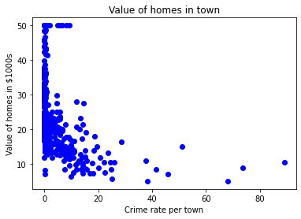

def mean(values):

return sum(values) / float(len(values))

# initializing our inputs and outputs

X = df['CRIM'].values

Y = df['MEDV'].values

# mean of our inputs and outputs

x_mean = mean(X)

y_mean = mean(Y)

#total number of values

n = len(X)

# using the formula to calculate the b1 and b0

numerator = 0

denominator = 0

for i in range(n):

numerator += (X[i] - x_mean) * (Y[i] - y_mean)

denominator += (X[i] - x_mean) ** 2

b1 = numerator / denominator

b0 = y_mean - (b1 * x_mean)

#printing the coefficient

print(b1, b0)

Output:

-0.4151902779150907 24.0331061741239

**CRIM versus MEDV**

b1 = -0.4151902779150907, b0 = 24.0331061741239

Y = b1X+b0

Model: Y = -0.4151902779150907X + 24.0331061741239

def predict(x):

return (b0 + b1 * x)

y_pred = predict(df['CRIM'].values)

print(y_pred)

[ 24.03048217 24.02176733 24.02177563 24.01966646 24.00443729

24.02071274 23.99644902 23.97309042 23.94540138 23.96250722

23.93973403 23.98433377 23.99416963 23.77163594 23.76823138

23.77261995 23.59552468 23.70751396 23.69982879 23.73176107

23.51337514 23.67934745 23.52139661 23.62271965 23.72160552

23.68412214 23.75413567 23.63627976 23.71216824 23.61689868

23.56360486 23.4706396 23.45682622 23.55492323 23.36347899

24.00646341 23.99265003 23.99983283 23.96042712 24.02163447

24.01915993 23.98019433 23.97435675 23.96694145 23.98216648

23.96193426 23.95490093 23.9379155 23.92770182 23.94185981

23.99626634 24.01509937 24.01085198 24.01242555 24.02745959

24.02766303 24.02457401 24.02716065 23.96898004 23.99022532

23.97110996 23.96181385 23.98732314 23.9805846 24.02500581

24.01822575 24.01492499 24.00907081 23.97683128 23.97989539

23.99646148 23.96719057 23.99505814 23.95198215 24.00032275

23.99361327 23.99095191 23.99695556 24.00966453 23.99828417

24.0160294 24.01458038 24.01791436 24.01836277 24.0121017

24.00929501 24.0115661 24.00341592 24.0096064 24.01109279

24.01365866 24.01678089 24.01565573 24.02116945 24.0152779

23.98243635 23.98534268 23.98293873 23.99911455 24.00462412

23.97138399 23.98564162 23.93812725 23.94524776 23.97514561

23.97804364 23.9620256 23.97864567 23.97995351 23.92364956

23.98829469 23.99123839 23.98191736 23.94088411 23.97402045

23.96196747 23.97847544 23.97042075 23.97889063 23.97300323

24.0044622 24.00335779 23.99449763 23.97066986 23.99221408

23.96293071 23.87228222 23.92550961 23.8979908 23.66721974

23.89191657 23.53780908 23.78812315 23.89616812 23.62780988

23.80152134 23.89914918 23.88682218 23.92939164 23.80702676

23.91232732 23.35691068 22.6542385 22.33190553 22.87898515

23.04522734 23.13835037 23.04967818 23.06530179 22.89798841

23.34530196 23.41184866 23.56536111 23.14078753 23.4460894

22.56540439 23.01726842 23.52508765 23.47557206 23.44145172

23.50437796 23.42553333 23.2717427 23.40242384 23.1021001

22.8190898 23.19849483 23.28564742 23.07800246 23.01608513

23.53179713 23.07239739 23.9753366 23.99500001 23.99803505

24.00543789 24.00395151 24.0105821 24.00552924 24.00910818

24.00575344 24.00450787 23.9953114 23.99155393 23.99861217

24.00799962 24.00984721 24.00040994 23.98087939 23.99835475

23.99545672 24.00441237 23.99713409 24.02402596 24.02713159

24.0273724 24.01645289 24.0137334 24.0174618 24.02002768

24.02572409 24.01880287 24.02406748 24.018533 24.024765

23.97646592 23.93774112 23.92848238 23.97669427 23.85220362

23.96067208 23.87708597 23.942931 23.97476364 23.91288783

23.9508902 24.0141735 24.00398888 23.98714876 23.98567068

23.88443069 23.86382895 23.77421012 23.77788871 23.90218422

23.81432996 23.87444536 23.86189001 23.90930059 23.84968341

23.81014899 23.84088968 23.79425136 23.89548305 23.8471383

23.89590655 23.81696642 23.82059933 23.99887789 23.99469277

23.98606927 23.98904618 23.99038309 23.98014035 23.94754376

23.95366782 23.89201206 23.95149222 23.96485304 23.95391693

23.97485498 23.94421809 23.99897338 23.87992587 24.01309815

24.01837522 24.02672055 23.77920071 23.75762327 23.76047148

23.80885775 23.81134474 23.8171491 23.69046625 23.80472246

23.71688895 23.70689117 23.79298503 23.80869583 23.99546918

23.90889785 23.96579968 23.98552537 23.94098376 24.00967283

23.9932313 23.9896399 24.00766747 23.99998229 23.94575844

24.01825067 24.01772337 24.00765916 24.02687417 24.02934455

24.02855569 24.02494769 24.01703416 24.01404894 24.01526545

24.01856621 24.00036427 24.01809705 23.9987907 23.99906472

23.97941377 24.01080215 23.97455189 24.00625997 24.01001744

24.01476722 24.01842089 23.99463464 23.99158715 24.01020843

24.0103579 24.00195445 24.01262899 23.82842567 23.88803869

22.9388805 23.70493563 23.92445503 23.92126222 23.87981792

23.92783053 23.90096356 23.93129321 23.86619138 23.83569565

23.96352028 23.95771177 23.88731626 23.91522535 23.89148892

23.95344777 23.90710838 23.93303286 24.00563303 24.00518878

24.01423993 24.01225117 24.01871568 24.01200205 24.01758636

24.01666049 24.0188776 24.02048024 24.01937998 24.01028316

24.00756782 24.02770455 24.02273472 24.02254789 24.02044702

24.0201813 24.00752215 24.02534212 24.02687417 24.02106981

24.00731871 24.00009855 24.00302979 24.02601057 24.01524884

23.98885104 20.30346852 22.43474816 21.87338184 22.26385169

22.14734515 22.44008751 22.50594499 22.2800109 22.5906189

22.14155324 22.49816848 18.4188202 21.99941285 21.6789856

21.31827659 20.19994497 20.60062435 19.42113105 16.35283338

15.8915985 17.68567721 19.95448863 14.21460344 16.61502604

-12.90894703 17.44220963 20.21874479 20.71470618 15.69405096

17.05301026 13.90503757 14.65100995 18.08189329 20.64858298

21.14248918 21.83548327 19.22607466 20.44388587 18.4862471

20.41399632 21.5950881 20.84775806 8.10981167 19.91585102

13.63420895 18.12237434 20.04906067 13.73568146 6.79058608

-4.16694965 15.43194134 19.07112564 20.95908303 18.03846438

2.80201916 18.19939214 16.22296186 12.13549661 5.0397702

16.52455607 19.53485167 13.26282125 -6.49753724 19.12875405

19.42972549 21.11739508 19.03081067 21.10584033 20.38270343

17.44806381 18.9481878 8.39625145 20.97435373 20.15568984

20.50725636 19.85533704 21.35759926 21.71590017 18.25639776

19.3994166 18.04573021 17.73168029 18.35409203 20.13420789

14.87770384 19.99572118 21.68048444 19.89509566 18.71771568

19.60227857 21.42236064 19.91240494 20.1597587 20.90837999

21.24397414 21.77399775 21.91971708 20.60857939 20.08313949

22.05996835 22.09465335 20.62830508 20.81445565 21.20932651

22.03515658 22.49976281 21.27004809 21.61622129 20.77829672

22.71961021 22.46577118 22.19701851 17.56622696 18.60445177

22.22753085 22.3563976 22.55142493 22.10376262 20.68842049

21.3787449 22.0105441 17.79553655 19.78446406 18.08189329

21.61503384 21.66312533 21.65358426 22.8629422 23.04554703

22.50783411 21.66994691 22.025383 23.97047057 23.95697273

23.9469708 23.98920395 23.98688719 23.96114955 23.91703143

23.95879127 23.91286707 23.92167741 23.93382587 23.95927289

23.93994578 24.00710281 24.01431051 24.00787921 23.98760547

24.013422 ]

#Scatter Plot

X = df['CRIM']

Y = df['MEDV']

plt.scatter(X,Y,color='blue')

plt.xlabel('Crime rate per town')

plt.ylabel('Value of homes in $1000s')

plt.title('Value of homes in town')

X = df['CRIM'].values

Y = y_pred

plt.plot(X, Y, color='red')

plt.show()

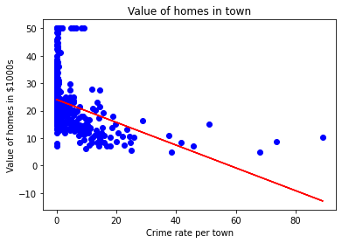

ZN

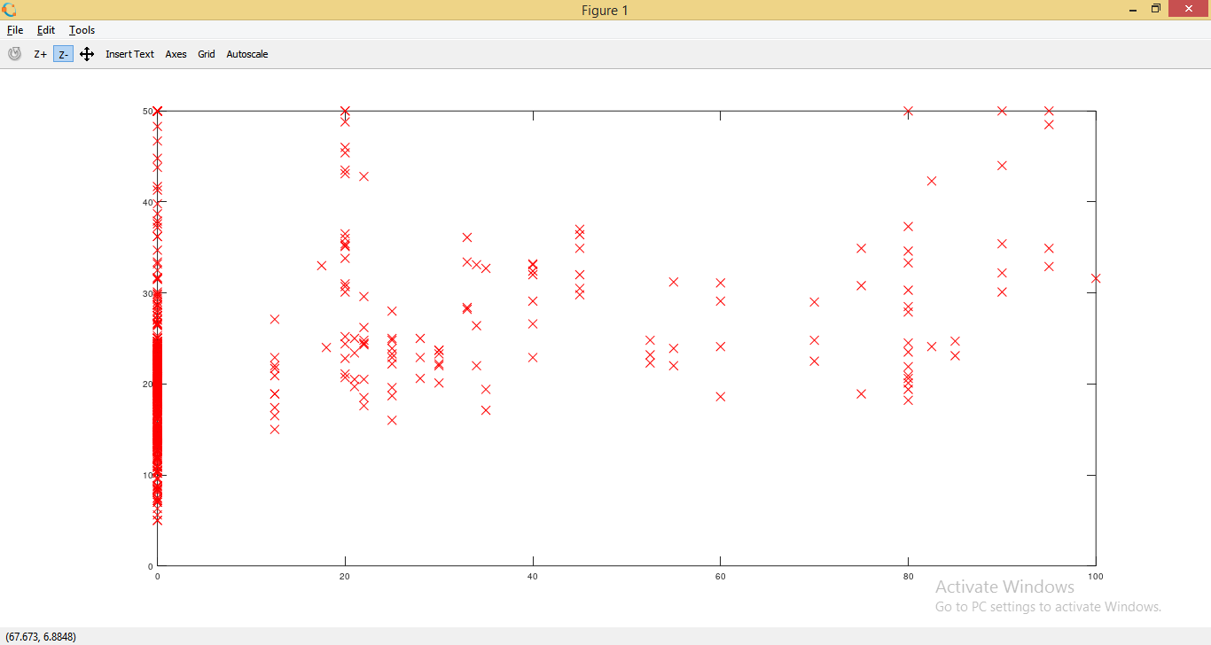

INDUS

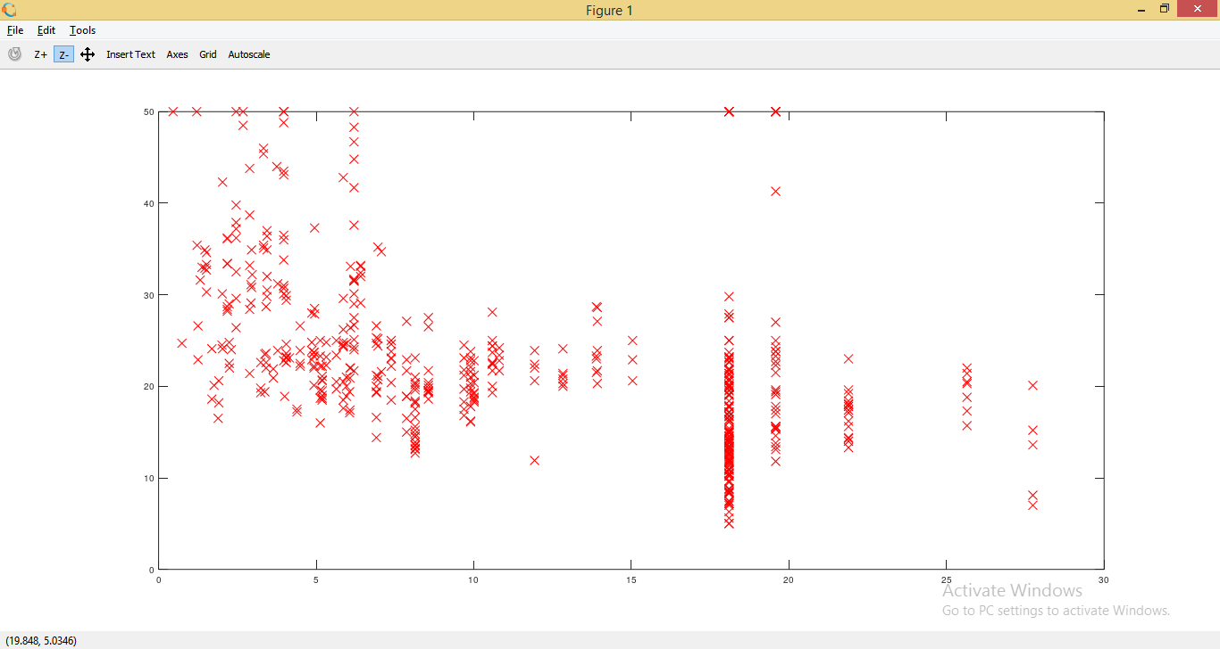

CHAS

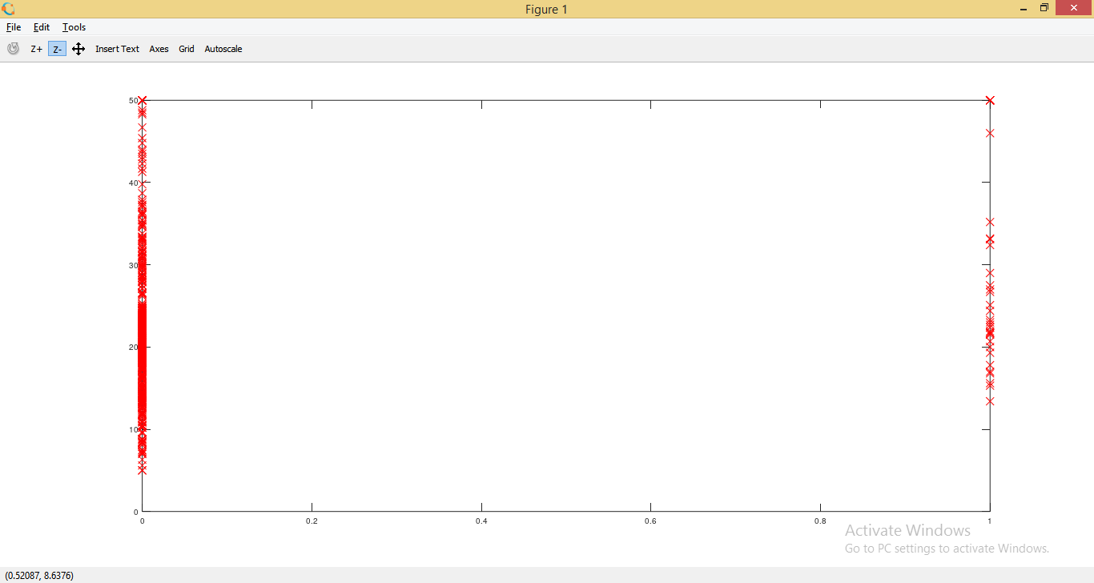

NOX

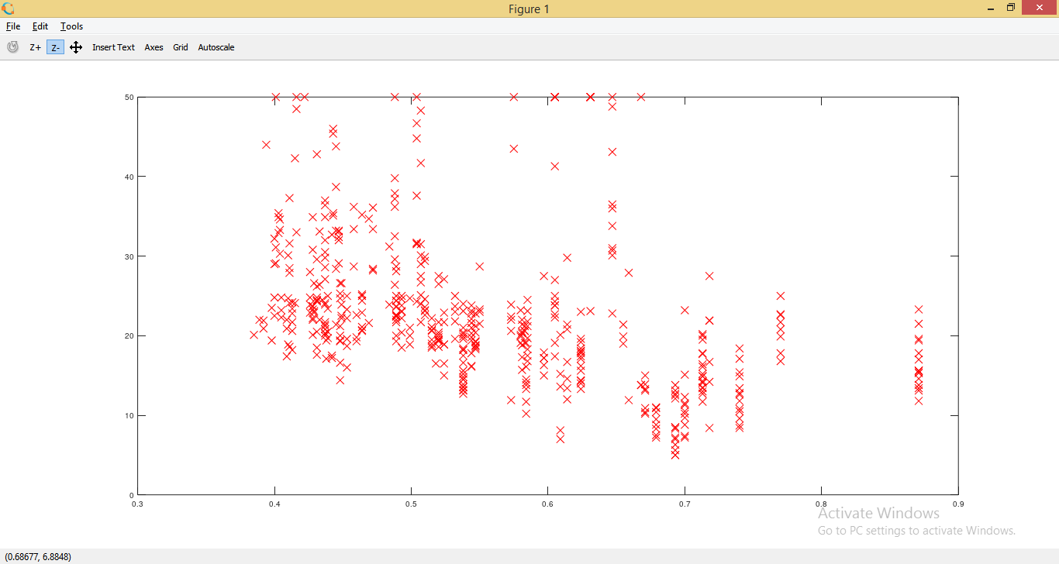

RM

#Scatter Plot

X = df['RM']

Y = df['MEDV']

plt.scatter(X,Y,color='blue')

plt.xlabel('Avg no. of rooms per house')

plt.ylabel('Value of homes in $1000s')

plt.title('Value of homes in town')

plt.show()

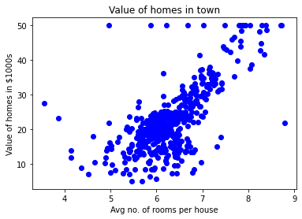

def mean(values):

return sum(values) / float(len(values))

# initializing our inputs and outputs

X = df['RM'].values

Y = df['MEDV'].values

# mean of our inputs and outputs

x_mean = mean(X)

y_mean = mean(Y)

#total number of values

n = len(X)

# using the formula to calculate the b1 and b0

numerator = 0

denominator = 0

for i in range(n):

numerator += (X[i] - x_mean) * (Y[i] - y_mean)

denominator += (X[i] - x_mean) ** 2

b1 = numerator / denominator

b0 = y_mean - (b1 * x_mean)

#printing the coefficient

print(b1, b0)

Output:

9.102108981180303 -34.67062077643857

**RM versus MEDV**

b1 = 9.102108981180303, b0 = -34.67062077643857

Y = b1X+b0

Model: Y = 9.102108981180303X + -34.67062077643857

def predict(x):

return (b0 + b1 * x)

y_pred = predict(df['RM'].values)

print(y_pred)

Output:

[25.17574577 23.77402099 30.72803225 29.02593787 30.38215211 23.85593997

20.05125842 21.50759586 16.5833549 19.97844155 23.3735282 20.02395209

18.93169901 19.47782555 20.81583557 18.43108302 19.35039603 19.85101202

14.99048582 17.45715736 16.02812625 19.6234593 21.23453259 18.23993873

19.25027283 16.29208741 18.23993873 20.36983223 24.44757706 26.07685456

17.32972783 20.59738496 19.48692766 17.22050253 20.81583557 19.33219181

18.49479778 18.57671676 19.63256141 25.35778795 29.26259271 26.95065703

21.48028953 21.86257811 20.57007863 17.04756245 17.99418179 20.21509638

14.47166561 16.31939374 19.60525508 20.98877564 24.5932108 19.92382889

18.9225969 31.31056723 23.42814085 27.36935404 21.26183891 19.27757916

17.58458688 19.63256141 24.09259481 26.87784015 29.99076143 22.58164472

18.0032839 18.83157581 16.24657686 18.89529058 23.73761256 19.58705086

20.53367019 22.17204981 22.42690886 22.54523628 22.48152152 21.21632837

22.05372239 18.79516738 26.55926634 25.57623857 22.69087002 21.46208531

23.4827535 25.67636177 20.07856475 21.0433883 29.10785685 29.7632087

23.73761256 23.62838725 23.96516528 21.86257811 22.20845825 25.63085122

21.42567687 38.77429659 36.50787146 32.83061943 26.55926634 27.05078022

23.62838725 21.18902204 21.46208531 18.58581887 18.44928724 21.09800095

24.25643277 22.02641607 21.71694436 26.45004103 19.15014963 20.77942714

22.25396879 19.28668126 21.54400429 20.1331774 18.77696316 17.49356579

18.75875894 19.97844155 19.58705086 18.63132942 18.84067792 19.81460358

16.41951693 17.14768565 23.86504208 16.63796755 24.11079902 22.90932064

23.32801765 18.32185771 17.73022063 22.99123962 19.41411079 24.07439059

18.64043153 21.31645157 21.52580007 11.0128642 14.50807405 15.09971113

9.95701956 21.12530728 16.55604857 10.16636806 12.5329164 16.27388319

21.05249041 14.51717616 10.94914944 17.2933194 21.11620517 21.32555368

13.31569777 28.52532188 20.5427723 24.58410869 22.21756036 33.49507338

36.34403349 41.55954194 18.6131252 20.86134612 37.50000134 18.82247371

22.84560588 23.60108092 18.80426949 18.84978003 16.04633047 23.72851045

18.65863574 24.91178461 20.12407529 22.80919744 27.76984683 28.86209991

36.00725546 21.2527368 30.45496898 25.06652047 16.33759795 21.33465578

36.60799466 27.05988233 25.0028057 30.72803225 28.59813875 26.66849165

30.66431749 27.2237203 25.43970694 37.00848745 31.65644737 30.01806775

31.53811995 28.81658937 30.2729268 21.41657477 34.59642857 36.80824105

38.45572278 18.94990323 22.90932064 17.96687546 20.52456809 13.97104962

19.57794875 14.51717616 18.18532608 23.35532398 14.58999303 21.59861695

18.9225969 25.78558708 19.49602977 23.33711976 28.59813875 21.43477898

27.94278691 25.56713646 40.56741206 44.74528008 38.51033543 30.52778586

35.28818885 24.96639727 19.76909304 32.79421099 41.2136618 40.39447199

26.55016423 20.72481448 25.68546388 32.30269711 24.32014753 25.45791115

28.10662487 20.80673346 23.20058813 23.51916194 16.23747476 16.34670006

20.92506088 21.99910974 23.8832463 26.47734736 24.37476018 23.92875684

28.65275141 40.5036973 20.92506088 18.8133716 33.17649957 44.5541358

32.07514438 27.60600887 30.89187022 33.77723876 41.76889045 32.02053173

30.91917654 15.93710516 29.17157162 40.84957744 33.32213331 19.21386439

18.63132942 22.12653927 24.83896774 35.3336994 26.84143172 27.71523418

31.47440519 27.46037513 24.32924964 27.3329456 36.50787146 28.7528746

34.91500238 37.44538868 29.84512768 24.06528848 22.03551818 21.84437389

22.80919744 25.08472469 27.77894894 30.39125422 25.67636177 21.09800095

20.02395209 26.113263 24.93909094 18.03059022 23.08226071 29.41732856

27.86997003 25.31227741 24.44757706 28.88030413 31.19223981 25.54893224

32.86702786 27.66972364 25.72187231 19.68717406 10.59416719 21.05249041

20.15138162 22.3631941 25.1029289 17.25691096 19.15925174 17.95777335

23.41903874 20.97057143 23.81953154 23.36442609 20.31521958 17.28421729

23.71940834 23.86504208 22.78189111 20.69750816 18.74055473 22.9730354

21.2527368 17.26601307 20.22419849 22.81829955 22.76368689 20.27881114

18.74965683 18.98631167 20.47905754 19.80550148 19.65076562 31.23775036

24.85717196 26.27710096 27.89727636 20.06946264 19.01361799 24.63872134

25.72187231 28.48891344 24.40206651 25.21215421 18.88618847 26.56836845

16.87462238 19.35949814 21.87168021 23.53736616 21.09800095 20.96146932

23.56467249 22.22666246 14.13488758 18.14891764 45.24589608 -2.25801069

10.5031461 0.49082622 10.56686086 26.15877354 29.18977584 21.90808865

18.80426949 9.98432589 2.99390619 31.8931022 25.84930184 27.16910764

23.40083452 21.97180341 28.7528746 24.90268251 15.71865454 15.5730208

5.08739125 13.36120832 7.6723902 10.83992413 9.74767105 14.38974663

17.32972783 20.40624067 11.16760005 21.69874014 18.9134948 24.22912644

23.62838725 17.63919954 14.9631795 18.59492098 19.82370569 23.06405649

23.61928514 14.01656016 15.673144 17.05666456 2.99390619 16.37400639

16.45592537 27.69702996 17.73022063 25.92211871 7.45393959 12.25075102

6.46180971 23.89234841 27.05988233 13.60696526 19.55064242 27.44217091

23.6829999 19.99664576 16.73809075 20.87955034 15.9826157 18.99541378

18.45838935 21.78065912 21.69874014 23.40083452 23.10956704 27.52408989

23.81042943 23.91055263 21.83527178 25.66725966 24.13810535 21.32555368

19.35039603 16.54694646 18.28544928 23.63748936 21.93539498 24.35655597

18.6131252 24.11990113 23.04585227 22.22666246 21.62592327 23.73761256

26.75951274 25.90391449 22.64535948 32.62127092 26.56836845 24.72064033

19.7235825 19.35949814 22.68176791 20.67930394 26.32261151 23.36442609

22.82740166 24.61141502 21.84437389 17.74842485 19.50513188 19.96933944

19.26847705 17.32972783 21.46208531 22.02641607 23.91965474 28.86209991

14.72652466 21.41657477 24.34745386 13.60696526 21.62592327 22.02641607

22.14474348 26.76861485 29.59937074 17.77573117 18.76786105 22.78189111

20.97967353 19.07733276 14.97228161 14.60819725 11.68642026 19.78729726

19.78729726 17.27511518 19.26847705 16.93833715 14.38974663 18.06699866

20.11497318 16.01902414 20.18779005 25.33958374 21.03428619 28.82569148

27.16910764 20.21509638]

#Scatter Plot

X = df['RM']

Y = df['MEDV']

plt.scatter(X,Y,color='blue')

plt.xlabel('Avg no. of rooms per house')

plt.ylabel('Value of homes in $1000s')

plt.title('Value of homes in town')

X = df['RM'].values

Y = y_pred

plt.plot(X, Y, color='red')

plt.show()

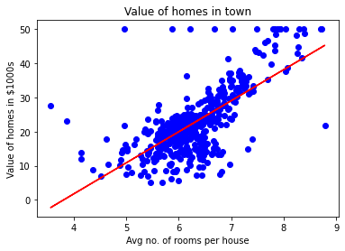

AGE

#Scatter Plot

X = df['AGE']

Y = df['MEDV']

plt.scatter(X,Y,color='blue')

plt.xlabel('Proportion built before 1940')

plt.ylabel('Value of homes in $1000s')

plt.title('Value of homes in town')

plt.show()

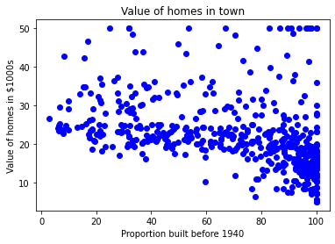

def mean(values):

return sum(values) / float(len(values))

# initializing our inputs and outputs

X = df['AGE'].values

Y = df['MEDV'].values

# mean of our inputs and outputs

x_mean = mean(X)

y_mean = mean(Y)

#total number of values

n = len(X)

# using the formula to calculate the b1 and b0

numerator = 0

denominator = 0

for i in range(n):

numerator += (X[i] - x_mean) * (Y[i] - y_mean)

denominator += (X[i] - x_mean) ** 2

b1 = numerator / denominator

b0 = y_mean - (b1 * x_mean)

#printing the coefficient

print(b1, b0)

Output:

-0.12316272123567955 30.978677762618055

**AGE versus MEDV**

b1 = -0.12316272123567955, b0 = 30.978677762618055

Y = b1X+b0

Model: Y = -0.12316272123567955X + 30.978677762618055

def predict(x):

return (b0 + b1 * x)

y_pred = predict(df['AGE'].values)

print(y_pred)

Output:

[22.94846834 21.26113906 23.4534355 25.33782513 24.30325827 23.74902603

22.77604053 19.14274025 18.66240564 20.39900001 19.36443315 20.76848817

26.17533163 23.36722159 20.57142782 24.01998401 27.37001003 20.91628344

26.47092217 22.41886864 18.89641481 19.99256303 19.68465623 18.66240564

19.38906569 20.42363255 19.85708404 20.04182812 19.35211688 20.2265722

19.38906569 18.66240564 20.87933462 19.27821925 19.04421007 22.57898017

23.41648668 25.86742483 27.25916358 28.29373044 29.03270677 30.62150587

30.1658038 30.17812007 26.05216891 26.81577778 26.87735915 20.4482651

19.24127043 23.34258905 25.3501414 23.21942632 28.37994434 28.34299553

25.11613223 28.28141417 26.58176861 25.99058755 27.3823263 25.16539732

22.82530562 19.4752796 22.62824526 25.63341566 23.65049585 28.78638132

27.14831713 28.34299553 26.44628962 26.91430796 30.1658038 28.82333014

30.01800854 30.21506889 30.23970144 25.43635531 21.80305503 25.33782513

24.36483963 26.47092217 26.8527266 22.30802219 27.01283814 25.22697868

25.06686714 24.0692491 25.42403903 23.9830352 20.34973492 23.20711005

22.83762189 21.87695266 24.3771559 27.41927512 21.45819941 23.85987248

22.40655236 21.61831095 26.43397335 23.28100769 21.13797634 22.19717574

20.46058137 20.21425593 19.89403285 19.06884262 19.66002368 20.48521391

19.01957753 19.74623759 24.27862573 20.92859971 19.53686096 19.22895416

20.60837663 20.11572575 22.04938047 20.80543699 21.97548284 22.94846834

22.39423609 20.62069291 19.53686096 19.0318938 19.17968907 20.09109321

19.20432161 19.15505652 18.8102009 19.31516806 18.79788463 18.9456799

18.92104735 19.22895416 18.85946599 18.88409854 19.46296333 18.85946599

18.88409854 18.92104735 19.45064705 18.66240564 18.66240564 18.66240564

18.93336363 18.66240564 18.66240564 19.19200534 19.42601451 19.29053552

18.99494499 18.66240564 20.14035829 18.84714972 19.15505652 20.80543699

19.40138197 18.98262871 18.66240564 18.66240564 19.57380978 19.79550267

18.88409854 19.41369824 19.67233995 19.52454469 19.13042398 21.22419024

19.14274025 19.2535867 19.32748433 18.99494499 20.07877693 20.62069291

22.51739881 26.90199169 25.16539732 21.93853402 21.8153713 23.78597484

20.71922308 23.3179565 19.62307486 19.20432161 19.9186654 22.50508254

24.3771559 25.91668992 27.39464257 26.18764791 28.33067926 27.18526595

27.73949819 29.75936682 28.6632186 27.03747068 26.77882897 26.47092217

26.26154554 29.09428813 29.26671594 26.24922927 29.04502304 26.88967542

27.04978696 28.23214908 24.5126349 22.02474793 23.69976094 18.66240564

19.63539114 20.06646066 24.35252336 27.00052187 29.77168309 25.75657838

24.08156537 20.49753019 19.42601451 19.59844232 20.07877693 19.73392131

21.40893432 21.02712989 21.33503669 20.7561719 20.32510238 21.13797634

28.8849115 28.34299553 22.59129645 21.5074645 21.9508503 22.30802219

22.7883568 23.40417041 21.55672959 22.16022692 28.70016742 25.78121093

24.290942 22.96078461 24.46336981 30.01800854 21.55672959 22.33265473

26.68029879 21.22419024 24.93138815 28.82333014 29.37756239 29.88252954

30.14117126 29.9441109 27.03747068 28.62626979 26.7665127 20.27583729

18.66240564 18.66240564 20.90396717 19.96793048 19.70928877 19.33980061

19.6969725 23.24405887 20.55911155 22.72677544 24.50031863 23.40417041

25.7935272 28.97112541 23.74902603 24.5988488 26.92662423 25.70731329

24.94370442 27.57938666 27.02515441 27.01283814 23.03468224 26.39702453

24.85749052 27.92424228 28.41689316 27.04978696 27.09905204 27.12368459

25.36245767 28.15825145 27.54243784 27.56707038 28.09667009 28.71248369

25.76889465 27.14831713 24.69737898 23.83523993 28.50310707 29.74705055

25.14076478 26.00290382 28.71248369 28.7986976 25.91668992 23.82292366

22.12327811 22.32033846 20.81775326 21.53209704 26.3231269 24.47568608

19.84476776 20.78080444 20.2265722 21.40893432 20.73153936 22.14791065

22.7021429 23.73670975 24.53726744 24.290942 24.83285797 21.82768757

26.03985264 29.16818576 27.41927512 25.59646684 27.80107955 28.86027896

27.01283814 27.48085648 28.10898636 26.28617808 26.236913 26.72956388

25.27624377 23.63817958 26.38470826 25.38709022 23.77365857 24.90675561

23.6258633 24.03230028 27.5178053 25.00528578 24.53726744 27.56707038

27.32074494 26.72956388 25.51025294 26.55713607 28.70016742 26.53250353

28.28141417 28.5770047 18.98262871 19.77087013 20.70690681 20.96554853

20.14035829 19.75855386 19.13042398 20.01719557 20.76848817 20.15267457

19.72160504 18.66240564 18.66240564 19.05652635 18.97031244 18.66240564

19.94329794 18.66240564 18.66240564 18.92104735 19.48759587 18.8102009

19.13042398 18.66240564 19.66002368 18.77325209 18.66240564 18.66240564

19.74623759 18.89641481 18.66240564 19.95561421 18.66240564 18.79788463

19.0318938 20.81775326 19.0318938 19.57380978 19.31516806 18.8102009

19.15505652 18.79788463 18.66240564 21.39661805 18.66240564 18.66240564

18.66240564 19.15505652 20.46058137 18.66240564 18.66240564 18.66240564

18.92104735 18.66240564 18.66240564 18.66240564 18.66240564 18.66240564

18.66240564 18.66240564 19.79550267 20.0048793 18.66240564 21.55672959

18.66240564 19.24127043 20.18962338 20.49753019 22.28338964 19.22895416

23.6258633 21.2857716 21.35966923 19.20432161 20.37436746 19.36443315

21.76610621 20.15267457 19.27821925 19.32748433 19.48759587 18.66240564

20.15267457 19.41369824 19.59844232 19.00726126 18.66240564 18.66240564

19.08115889 19.30285179 19.10579144 19.08115889 18.82251718 18.87178227

19.57380978 18.88409854 19.67233995 18.74861954 19.38906569 20.32510238

20.15267457 21.08871125 20.669958 20.58374409 19.89403285 20.09109321

20.7561719 19.90634912 22.92383579 25.0422346 20.54679527 19.33980061

22.23412455 23.99535147 20.63300918 19.80781895 21.74147367 22.65287781

19.22895416 18.98262871 19.45064705 18.99494499 19.06884262 20.14035829

23.0100497 21.75378994 21.49514823 26.0152201 25.81815974 24.58653253

21.15029261 24.42642099 19.5614935 18.87178227 18.90873108 18.8102009

20.69459054 24.32789082 25.73194584 27.43159139 22.00011538 22.28338964

22.93615207 21.92621775 21.16260888 22.46813373 21.53209704 19.77087013

19.98024676 21.02712989]

#Scatter Plot

X = df['AGE']

Y = df['MEDV']

plt.scatter(X,Y,color='blue')

plt.xlabel('Proportion built before 1940')

plt.ylabel('Value of homes in $1000s')

plt.title('Value of homes in town')

X = df['AGE'].values

Y = y_pred

plt.plot(X, Y, color='red')

plt.show()

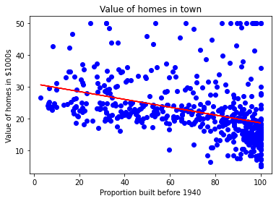

DIS

#Scatter Plot

X = df['DIS']

Y = df['MEDV']

plt.scatter(X,Y,color='blue')

plt.xlabel('Distances to employment centres')

plt.ylabel('Value of homes in $1000s')

plt.title('Value of homes in town')

plt.show()

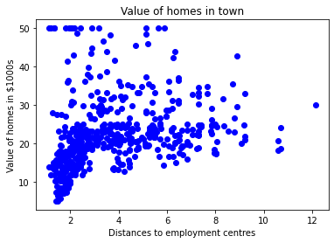

def mean(values):

return sum(values) / float(len(values))

# initializing our inputs and outputs

X = df['DIS'].values

Y = df['MEDV'].values

# mean of our inputs and outputs

x_mean = mean(X)

y_mean = mean(Y)

#total number of values

n = len(X)

# using the formula to calculate the b1 and b0

numerator = 0

denominator = 0

for i in range(n):

numerator += (X[i] - x_mean) * (Y[i] - y_mean)

denominator += (X[i] - x_mean) ** 2

b1 = numerator / denominator

b0 = y_mean - (b1 * x_mean)

#printing the coefficient

print(b1, b0)

1.0916130158411101 18.390088330493406

**DIS versus MEDV**

b1 = 1.0916130158411101, b0 = 18.390088330493406

Y = b1X+b0

Model: Y = 1.0916130158411101X + 18.390088330493406

def predict(x):

return (b0 + b1 * x)

y_pred = predict(df['DIS'].values)

print(y_pred)

Output:

[22.85478557 23.81223934 23.81223934 25.00766476 25.00766476 25.00766476

24.46000251 24.88573158 25.02938785 25.58611049 25.31822866 25.1872351

24.34036172 23.5288566 23.26075645 23.30081864 23.30081864 23.03806739

22.53439715 22.53439715 22.5359254 22.76996723 22.73132413 22.86046195

23.19274895 23.25278767 23.50102047 23.25147774 23.25289683 23.0174359

23.01088623 22.94757267 22.74562426 22.52424514 22.49433495 22.05823555

22.07744794 22.68471226 22.58985109 24.28599939 24.28599939 24.63509723

24.63509723 24.63509723 24.63509723 23.95775136 23.95775136 24.60071142

24.79785673 25.03550089 25.82910355 25.82910355 25.82910355 25.82910355

26.38036812 27.88341008 28.41939207 27.47754836 26.92082573 25.95714976

26.27742902 25.83325168 26.27753818 27.10214265 28.45792601 25.60728778

25.60728778 25.48338971 25.48338971 25.48338971 24.16177383 24.16177383

24.16177383 24.16177383 23.03108107 23.3051851 22.81352259 22.85533137

23.86354515 23.3051851 24.28556275 24.28556275 24.28556275 24.28556275

23.60734358 23.23433941 23.22287747 22.48101727 22.12526059 22.11740097

21.76568326 21.76546494 22.39183249 22.39183249 22.33626938 22.20549414

22.20549414 22.20549414 22.20549414 22.20549414 21.42237097 21.50784427

21.35349018 21.35349018 21.03288344 20.69000779 20.80364471 20.7069278

21.04587364 21.16835262 21.42237097 21.31288218 20.9590904 21.17151829

20.8533131 21.07884035 21.37030103 21.38918593 21.09455958 21.40206696

20.85462304 20.78879877 20.66817553 20.51262068 20.58019152 20.56556391

20.30827072 20.34221989 20.36863692 20.55137294 20.7026705 20.86914149

20.93070846 21.08626332 20.95101247 20.69415592 20.53718197 20.40935409

20.21155381 20.21166297 20.14965935 19.96135611 19.83276409 19.93122759

19.85929029 19.93919636 20.04562863 19.98471662 20.0598196 20.05556231

20.15631819 20.12749961 20.14780361 20.16199458 20.29975614 20.29549885

20.28556517 20.43937345 20.30837988 20.31776776 20.35324518 20.54154842

20.61774301 20.75015567 21.03397505 20.88267749 20.6234194 21.03823235

20.68247566 20.85986278 21.03823235 20.99762434 21.22402488 21.27882385

21.33951754 21.80934778 22.27066344 22.01151451 21.57246776 21.47826155

21.38219961 21.22598978 21.33809844 21.49791059 21.65171886 21.97025154

21.88237669 22.5257734 23.37515749 23.37515749 25.46352235 25.46352235

25.46352235 25.17948464 25.17948464 24.55595529 26.36868786 26.36868786

26.36868786 26.74463939 26.74463939 25.23450194 25.23450194 23.97696375

23.97696375 22.69693832 23.14395385 23.14395385 23.01765423 22.62008877

22.62238115 22.39085003 22.37731403 22.69693832 22.30625002 22.69693832

21.7872972 22.12460562 21.54408582 22.06151039 21.5139573 21.7173248

21.96195528 21.96195528 21.54965304 21.54965304 21.90038831 21.90038831

22.07439142 22.07439142 22.39794552 22.39794552 22.58013573 22.3765499

22.3765499 22.3765499 22.91809912 22.91809912 25.14706374 25.14706374

25.30665756 25.30665756 26.0701317 26.0701317 27.07376071 27.07376071

27.18357698 27.18357698 26.9335976 26.9335976 26.46442232 26.46442232

28.11275798 28.11275798 28.45508782 28.45508782 25.30665756 20.35608337

20.45825835 20.58499462 20.69568418 20.72592186 20.88824472 20.65933347

20.49701061 20.55857759 20.71838973 21.03353841 21.52520091 22.66648232

23.22484238 23.22484238 22.66648232 23.15661656 22.84124956 23.04832855

23.61585816 23.6983841 22.9096937 22.86646582 23.51488396 24.11527111

24.07946621 24.81423093 26.36683212 26.36683212 28.31197735 26.37763909

26.37763909 26.37763909 23.97554465 23.97554465 23.97554465 24.39690727

24.39690727 24.89653855 24.89653855 25.28908259 26.9350167 26.9350167

26.9350167 24.38489953 24.38489953 24.38489953 22.78055588 22.06882419

21.77321539 21.86436508 22.01151451 21.77681771 21.14029816 21.27227418

21.48371962 21.95180328 22.3224059 22.69650168 22.75501214 22.79114453

22.24621131 22.75861446 23.34644807 23.34644807 23.54370254 23.54370254

23.54370254 24.30215526 24.30215526 24.30215526 24.08241356 24.08241356

24.80178654 25.63916288 25.63916288 25.44016183 25.44016183 24.92371971

24.10042518 24.51949541 23.64314849 23.64314849 23.64314849 26.07275157

25.23111794 24.6473233 25.44780312 27.13783839 27.13783839 27.7073329

27.49850733 27.98765913 27.98765913 30.08159121 30.08159121 31.62753357

29.94557623 29.94557623 20.70670947 21.12479726 21.36222309 21.12905455

21.13898823 20.89588601 20.68640547 20.46928364 20.46928364 20.15107845

20.30292182 20.03907895 19.84466267 19.87107971 19.70264382 19.66629311

19.62317439 19.67186033 19.63125233 19.82697854 19.85819868 19.87249881

19.90317313 19.90317313 19.93635817 20.04846682 20.11527354 20.06364025

19.96146527 19.94683765 19.99170295 20.04759353 20.12520722 20.27650478

20.49308081 20.75648703 20.32224337 20.34538556 20.33545189 20.27388491

20.22050504 20.17312903 20.01615508 20.0279445 20.12444309 20.10839638

20.17924206 20.24888697 20.14474709 19.94607352 19.67611762 19.79302938

19.97805778 19.98984721 19.93253752 20.05752721 20.0863458 20.12509806

20.20020103 20.39287073 20.37627821 20.18852077 20.35782995 20.34844208

20.41928777 20.43642609 20.52004365 20.59711153 20.64263179 20.47463255

20.57069449 20.42365422 20.50301448 20.53860107 20.63084237 20.66959463

20.79207361 20.91804575 20.81587077 20.70943851 20.57615256 20.47965397

20.37747899 20.3737675 20.42725654 20.64437837 20.5785541 20.54973552

20.45934996 20.56010584 20.6519105 20.78945374 20.85888033 20.77526277

20.92656033 20.96105531 20.97524627 21.06748757 21.11486358 21.04903931

21.20710488 21.42389922 21.42815651 21.3565467 21.22555314 21.1923681

21.37499496 21.44835136 21.62497434 21.73751964 21.52465511 21.16311287

21.56493563 21.472476 21.70138725 21.77332455 21.55194543 21.15503494

21.04248964 20.79818664 20.90658382 20.68323979 20.75943438 20.52004365

22.12798962 22.02701542 22.11314368 22.86384595 22.4552552 22.74748001

22.26083892 21.83118004 20.37780647 20.30630582 20.37966221 20.42933061

20.69328263 20.98998305 20.98998305 21.44507652 21.44507652 21.5477973

21.01989325 21.00985041 21.11715597 21.09576035 20.8871531 20.75615954

20.99784266 21.12457894]

#Scatter Plot

X = df['DIS']

Y = df['MEDV']

plt.scatter(X,Y,color='blue')

plt.xlabel('Distances to employment centre')

plt.ylabel('Value of homes in $1000s')

plt.title('Value of homes in town')

X = df['DIS'].values

Y = y_pred

plt.plot(X, Y, color='red')

plt.show()

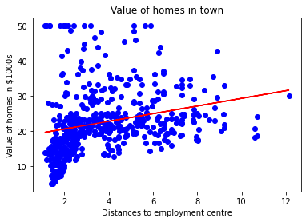

RAD

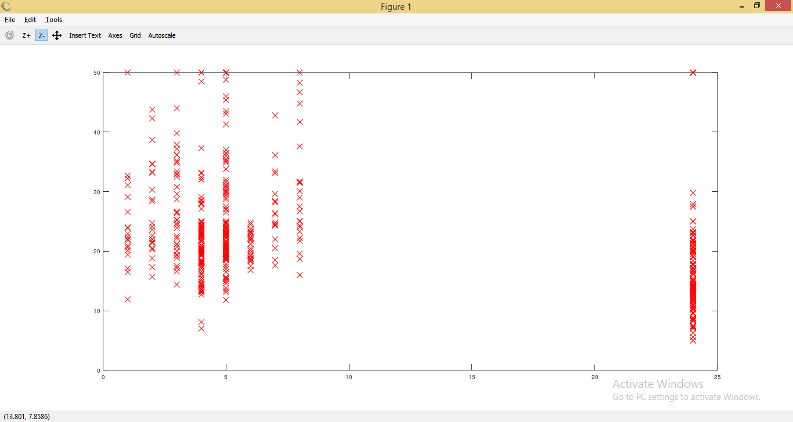

TAX

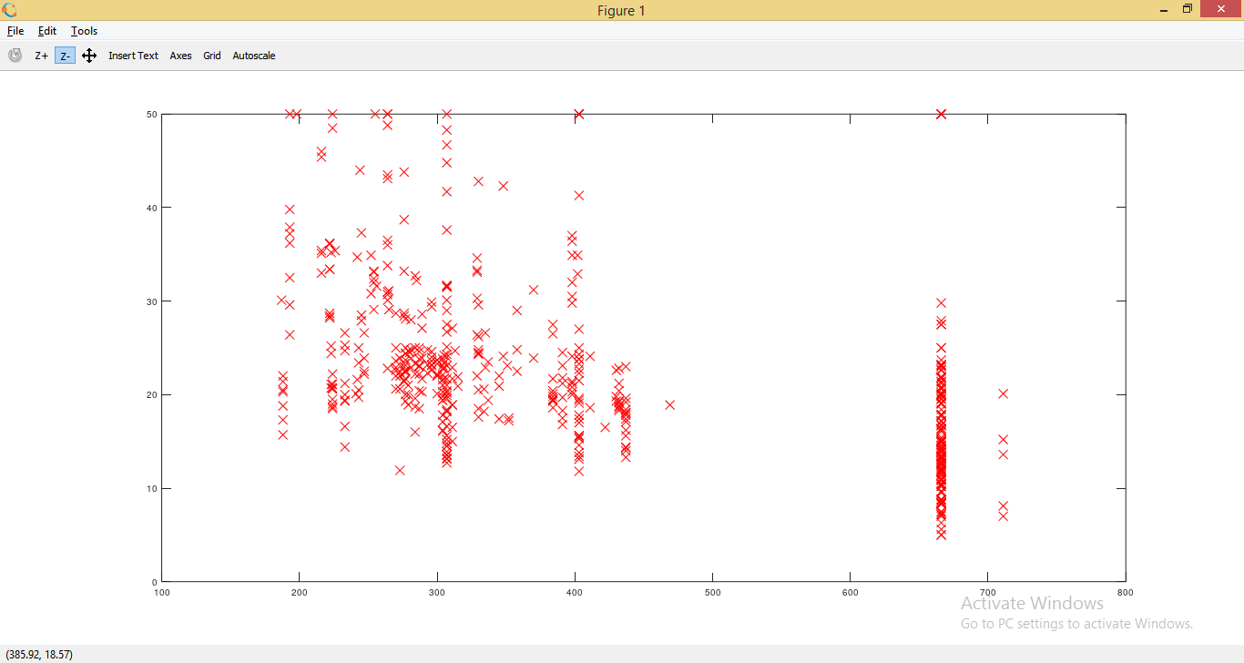

PTRATIO

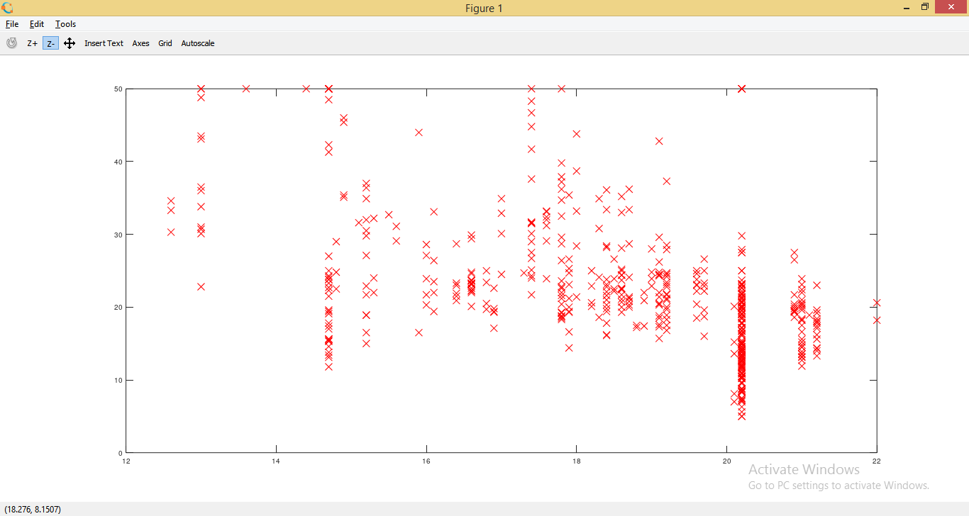

B

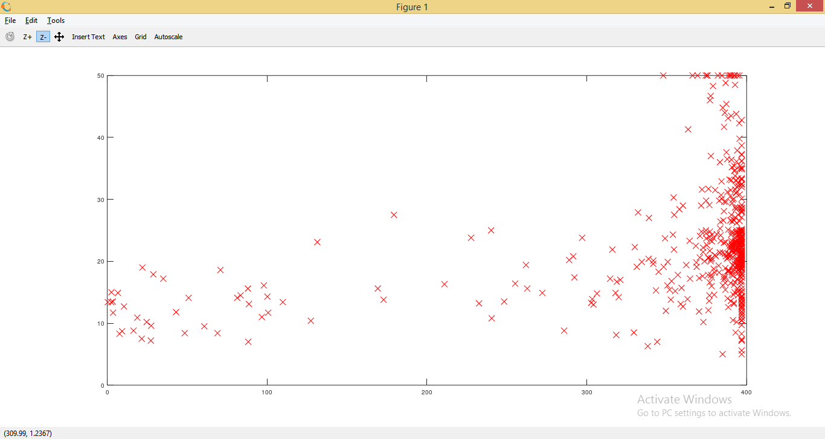

LSTAT

#Scatter Plot

X = df['LSTAT']

Y = df['MEDV']

plt.scatter(X,Y,color='blue')

plt.xlabel('% of lower status population')

plt.ylabel('Value of homes in $1000s')

plt.title('Value of homes in town')

plt.show()

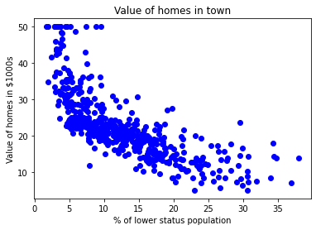

def mean(values):

return sum(values) / float(len(values))

# initializing our inputs and outputs

X = df['LSTAT'].values

Y = df['MEDV'].values

# mean of our inputs and outputs

x_mean = mean(X)

y_mean = mean(Y)

#total number of values

n = len(X)

# using the formula to calculate the b1 and b0

numerator = 0

denominator = 0

for i in range(n):

numerator += (X[i] - x_mean) * (Y[i] - y_mean)

denominator += (X[i] - x_mean) ** 2

b1 = numerator / denominator

b0 = y_mean - (b1 * x_mean)

#printing the coefficient

print(b1, b0)

Output:

-0.9500493537579905 34.553840879383124

**LSTAT versus MEDV**

b1 = -0.9500493537579905, b0 = 34.553840879383124

Y = b1X+b0

Model: Y = -0.9500493537579905X + 34.553840879383124

def predict(x):

return (b0 + b1 * x)

y_pred = predict(df['LSTAT'].values)

print(y_pred)

Output:

[29.8225951 25.87038979 30.72514198 31.76069578 29.49007782 29.60408375

22.74472741 16.36039575 6.11886372 18.30799693 15.1253316 21.94668596

19.62856553 26.70643322 24.80633451 26.50692285 28.30251613 20.61661686

23.44776393 23.83728417 14.58380346 21.41465832 16.76891698 15.66685973

19.06803641 18.86852605 20.48360995 18.13698805 22.39320915 23.17224962

13.08272548 22.16519731 8.22797329 17.12043524 15.22983702 25.35736314

23.71377775 26.22190805 24.92984093 30.44962767 32.67274316 29.95560201

29.03405413 27.48547369 25.48086955 24.85383698 21.11064252 16.69291303

5.28282029 19.16304135 21.77567707 25.59487547 29.53758029 26.54492483

20.49311044 29.98410349 29.07205611 30.80114593 28.03650231 25.79438584

22.06069188 20.83512821 28.16000873 25.52837202 26.90594358 30.1171104

24.8253355 26.85844111 22.11769484 26.20290706 28.16950922 25.16735326

29.30956845 27.39046875 28.11250626 26.06039966 23.18175011 24.79683402

22.83023185 25.90839176 29.5280798 27.69448455 28.16950922 27.41897023

25.4143661 28.3500186 22.33620619 26.53542433 29.32856943 29.13855956

26.18390607 26.76343618 26.80143815 28.65403439 24.49281822 28.23601268

23.78028121 30.5541331 31.16216469 28.67303538 25.60437597 27.26696234

24.45481625 21.78517756 22.83973235 18.90652802 16.82591994 21.16764548

22.89673531 19.78057343 22.20319928 24.90133945 19.15354085 18.31749742

24.62582513 19.58106306 23.11524666 24.76833254 19.95158231 21.62366917

20.90163167 20.9966366 17.51945597 10.4130868 17.85197324 20.48360995

8.6554955 18.22249249 19.93258133 17.12993573 22.58321902 22.9062358

23.98929207 20.27459909 18.10848657 18.44100384 18.4980068 20.69262081

14.29878866 17.01592981 11.60064849 1.86264262 9.07351721 9.45353695

6.72689531 8.14246884 18.73551914 6.49888346 7.64844318 14.17528224

21.15814499 21.93718546 23.03924271 19.55256158 20.18909465 20.28409959

19.22004431 30.19311435 28.44502353 27.53297616 29.32856943 32.9102555

32.72974612 31.39967702 23.4952664 25.23385672 31.03865827 23.02024172

24.00829305 23.79928219 20.8446287 23.12474715 20.59761587 25.96539472

25.39536511 29.49007782 24.94884191 28.57803044 27.97949935 29.76559214

27.37146776 25.57587449 29.97460299 29.15756055 21.27215091 22.06069188

30.32612126 28.2075112 30.22161583 29.43307486 29.70858918 30.09810941

31.82719923 29.77509263 30.39262471 31.7321943 30.67763952 26.37391594

28.26451416 30.22161583 30.32612126 27.49497418 31.59918739 30.93415284

31.81769874 24.2268044 24.13179947 17.39594955 20.62611735 12.6172013

18.14648854 11.77165738 19.32454974 25.64237794 6.47988248 25.5568735

21.71867411 25.34786264 17.52895646 24.57832266 25.32886165 14.16578175

25.1198508 27.33346579 30.62063655 30.15511237 31.5801864 28.51152699

30.82964741 30.98165531 23.48576591 29.56608177 32.20721898 30.80114593

26.90594358 24.21730391 25.49037004 30.06010744 28.51152699 27.55197714

23.74227923 22.77322889 23.89428713 29.62308473 22.67822396 17.01592981

25.8513888 24.91083994 25.50937103 28.32151712 28.94854969 31.1431637

31.20016666 31.19066617 28.31201663 25.76588436 31.59918739 29.68958819

27.15295641 27.99850034 25.44286758 27.65648257 28.9390492 23.86578565

26.85844111 24.62582513 20.50261094 27.48547369 31.55168492 21.5856672

22.20319928 28.29301564 27.20995937 28.30251613 31.20016666 31.72269381

28.80604229 30.60163557 27.72298603 29.94610151 30.98165531 30.19311435

31.69419232 31.55168492 27.09595345 26.7349347 22.26970274 27.77048849

27.33346579 25.51887153 31.39017653 31.17166518 30.08860892 26.40241742

24.6733276 28.59703143 27.53297616 19.50505912 29.83209559 30.05060694

28.7870413 25.52837202 26.31691298 29.93660102 27.96999886 26.06990015

28.40702156 27.39996925 30.24061681 25.08184882 22.54521705 28.87254574

23.41926245 27.04845098 25.73738288 23.62827331 17.13943622 19.41005418

24.71132957 22.45971261 27.71348553 28.02700182 27.23846086 23.40026147

28.73953883 29.72759016 28.71103735 22.40270964 25.08184882 27.58047862

25.91789225 22.74472741 27.11495444 29.15756055 28.14100774 26.94394556

25.24335721 24.5213197 26.46892088 25.30036017 25.72788238 29.33806993

26.33591397 27.73248652 30.17411336 24.54982118 22.51671557 28.51152699

28.86304525 28.95805019 28.87254574 29.33806993 27.15295641 30.27861879

26.90594358 29.26206598 17.83297225 21.94668596 23.6472743 22.51671557

27.15295641 21.07264055 24.87283796 20.64511834 29.5280798 27.78948948

21.25314993 21.88968299 31.45667999 31.01015679 31.74169479 25.49987054

26.11740262 1.52062485 -1.51953308 21.78517756 12.4746939 14.37479261

12.04717169 13.86176595 18.2034915 14.5268005 12.13267613 11.22062875

5.45382917 5.28282029 7.68644516 4.16176205 5.46332967 14.74531185

18.29849644 16.730915 10.15657347 20.14159218 19.02053395 18.28899594

16.1513849 15.62885775 5.49183115 6.08086175 9.12101968 15.24883801

15.2583385 15.77136516 8.54148957 12.72170673 12.37968896 23.02974222

9.47253794 15.76186466 24.94884191 14.39379359 1.90064459 15.47684986

-0.57898422 6.95490715 10.05206805 9.2445261 14.9638232 12.94971857

20.28409959 19.63806603 21.15814499 12.42719143 18.25099397 11.38213714

19.64756652 20.75912426 14.10877879 11.67665244 17.79497028 15.8473691

23.12474715 19.14404036 20.14159218 12.44619242 17.40545004 9.42503547

2.23316186 12.81671167 13.54824967 16.00887749 18.7925221 16.64541056

11.95216675 11.77165738 17.65246288 18.9350295 17.3294461 16.20838786

17.98498015 17.70946584 18.14648854 18.6500147 16.77841747 17.3294461

16.49340266 18.46000483 19.13453987 20.58811538 18.95403049 20.63561785

21.26265042 24.77783303 21.99418842 21.12964351 18.26049446 14.29878866

17.3294461 20.53111242 19.07753691 22.3267057 20.91113216 23.47626541

17.3199456 11.65765145 16.80691895 10.88811148 17.42445103 22.09869385

24.35031082 27.20045888 27.89399491 24.65432661 21.8801825 24.50231872

20.32210156 23.67577578 17.39594955 11.78115787 6.35637606 17.38644906

21.87068201 23.14374814 21.64267016 17.83297225 14.46979754 21.15814499

22.27920323 20.20809564 20.93963364 25.36686363 25.92739275 29.19556252

28.39752107 27.06745197]

#Scatter Plot

X = df['LSTAT']

Y = df['MEDV']

plt.scatter(X,Y,color='blue')

plt.xlabel('% of lower status population')

plt.ylabel('Value of homes in $1000s')

plt.title('Value of homes in town')

X = df['LSTAT'].values

Y = y_pred

plt.plot(X, Y, color='red')

plt.show()

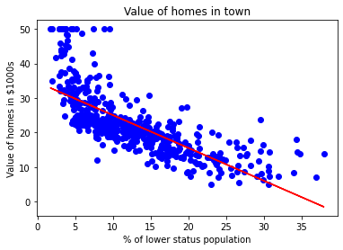

The features RM, LSTAT, AGE, DIS, and CRIM are used for the models because they show regular patterns when plotted on graphs against MEDV, unlike features ZN, INDUS, CHAS, NOX, RAD, TAX, PTRATIO and B which show irregular graph patterns when they are plotted against MEDV.